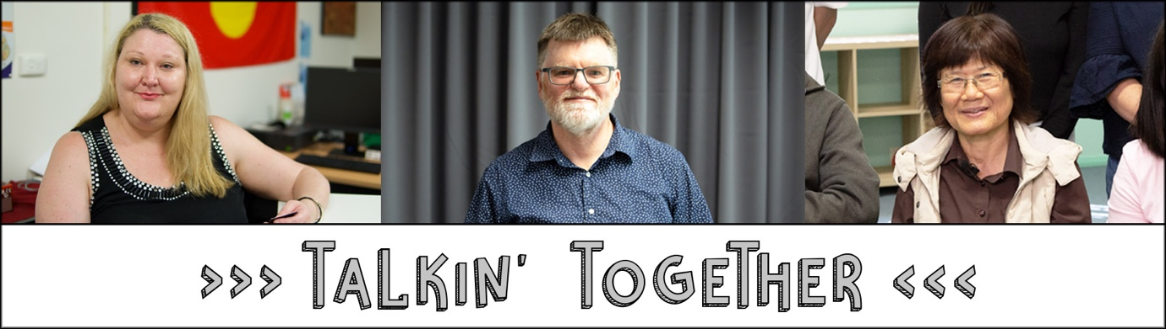

The Talkin’ Together Toolkit

Welcome to the Talkin’ Together Toolkit.

This toolkit is based on our experiences in the Talkin’ Together Project.

This toolkit brings together what we learned from working with each other, as well as a whole lot of research and resources that helped us and can help you to:

- Engage with communities
- Work alongside peers
- Co-design

Who is this TnT Toolkit for?

Click here if this is you:
- Are you interested in getting better outcomes from your programs?
- Are you wanting more engagement from communities that you find difficult to engage with?
- Are you looking for greater impact in your project, program or initiative?
- Are you wanting more ‘bang for your buck’?
Are you frustrated with doing the same things again and again and continually missing the mark?
- Are you looking to do better, do more, or do things in a new way?

If you ticked one or more of the above, this toolkit might be for you.

You might:
- Be working for a government agency
- Be working for a company
- Be working for a non-government agency
- Be involved in a peer group
- Be involved on the board of an organisation
- Be involved with your local neighbourhood centre, or
- Simply want to change how things are done in your local community.

If you are, this toolkit really is for you.

What is Talkin’ Together?

Check out our promo video for a speedy introduction to Talkin’ Together.

(To access the videos in this toolkit, you need to be online. When you see an image with a red box and a white forward triangle (note: this is Alt text image described as video), please double click on the image and this will take you to the relevant video)
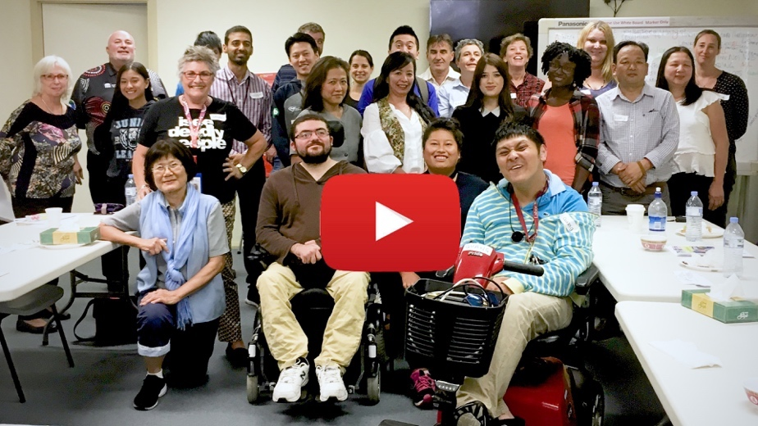
Video transcript

And if you are wanting some more info, read here the “About the TnT TnT “

And you might like to know what the independent evaluators said, by downloading their presentation (PDF only)

First up, meet Suzy and Dave, your toolkit guides.

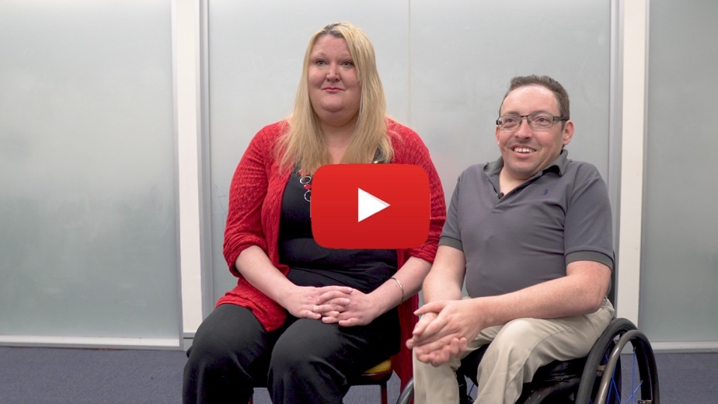

video transcript

How does the toolkit work?

As Dave and Suzy said, there are three topics tin this toolkit:

Topic 1: Engage with communities
This is all about your first engagement with a community and why. There are also some principles you might want to consider and some ‘how to’ ideas.

Topic 2: Work alongside peers:
This topic explores some really important ideas such as ‘Nothing about us without us’ as well as the importance of the expertise that comes from having lived experience. There are also some of the ‘how to’ questions we had to work through as part of our work.

Topic 3: Co-design
The co-design section builds on the first two topics and is the core of the toolkit. We will guide you through the 4 steps of co- design: Discover, Develop, Deliver and Debrief. You will find loads of original resources and ideas for you to think about and test.

You can start at Topic 1 and work your way to the end or you can dip in and out.

In each topic you will find:
- Loads of content to read
- Videos to watch and think about
- Downloadable resources you can use to work through some of the issues
- Lots of links to resources that you might find useful

In this downloaded version of the toolkit, you can click on the hyperlinks to watch videos and read subtitles of videos and additional documents which are at the end of this toolkit

How long does it take to go through the whole kit?

You could spend hours and hours, following all the links and then checking out some of the suggested searches, getting side-tracked, following interesting leads and issues of particular interest to you!

But, if you work through the toolkit bit by bit, watch some of the videos and stay focused,
it should take you about 2- 2.5 hrs to go through it all.
Let’s start.

Topic 1: Engage with Communities

Welcome to Topic 1 in your TnT Toolkit.

This topic will briefly introduce you to some of the principles and actions involved in engaging with communities as your first step towards co-design.

We assume you are here reading this toolkit because you are thinking about a project or an initiative you want to undertake, and you have decided (probably based on your previous experiences) that a top-down approach to your project might not work so well.

You are also here because you have worked out that modern society is complex. You have worked out that there is not one community but many communities. And you know that even within one community, such as the community of people with disability, there are people with many different experiences (make sure you check out the videos on ‘intersectionality’ in Topic 3 of this toolkit).

To start us off on this topic, let’s have a look at what Emma had to say about why Fair Trading decided to engage with different communities.

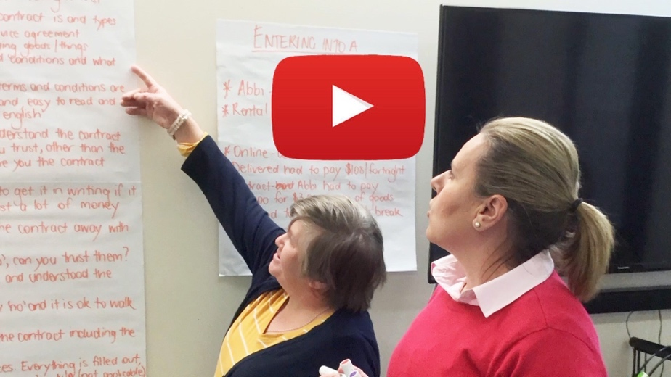

Video Transcript

Emma is pretty clear about the why. It’s about making a resource, program or initiative work for everyone in the community. Emma is also pretty clear that if a mainstream government agency such as NSW Fair Trading can make it work, so can anyone.

But what about the how?

Community engagement is a theory, principles and practices that takes up rows and rows in every university library that teaches social work, community development, social psychology and other related courses. So if you wanted to delve really deep, there are plenty of resources to check out.
If your time is more limited, we suggest you check out “1 Community @ a time”).
While this resource was designed for engaging with multicultural communities, the ideas will also work for other communities.

If you have even less time, below are some of the key ‘need to know’ elements about engaging with communities before you actually do it:

What is Community Engagement?

“Community Engagement is the process of working collaboratively with and through groups of people affiliated by geographic proximity, special interest, or similar situations to address issues affecting the well-being of those people.”
(National Institute of Health (US) (2011): Principles of Community Engagement)

What are the principles of Community Engagement?

- Working from a human rights framework: This means all our engagements must enhance, not diminish, the human rights of all the people we engage with.
- Using strength-based approaches to build social capital: We start our work with communities with a focus on the gifts and the possibilities each community brings rather than on the problems and deficits.
- Have clarity of purpose: Get clear on your purpose and articulate this purpose to the community you are collaborating with. For example, if your purpose is to promote your own services, please don’t pretend you want to work in partnership with a community to achieve a goal they have identified.

Community Engagement resources

If you want to know more, two useful resources to have a look at and learn about networking, processes and more are:
Walking the Talk: A framework for effective engagement with people with disability, families and people who support them (pdf only)

If you want something a bit more official, check out this Australian government resource “Protocol for engaging with people with disability”.

And there is just one more thing before you go out and connect.

The Power of Language

Have a think about the language you will use.

What style of language will you use and what terms will you use to address people?

This might be your first meeting and you do not want everything to come to a grinding halt before you have even started because the language and tone you used was too bureaucratic, offensive, not clear, overly complicated, or patronising.

In the last section of this Toolkit, we share some of what we learned and some resources about the use and usefulness of easy read/ plain English. We really encourage you to have a read of that before you connect with anyone (because it works!)

Derogatory language impacts people of all the identity groups identified below. Language has been used to isolate, denigrate, stigmatise, and make people ‘other’. Our everyday language is full of words that are offensive.

Please pay attention to the language you use and the terms you use to refer to the people you want to engage with.

What terms to use?

Aboriginal and Torres Strait Islander peoples:

The term Aboriginal and Torres Strait Islander peoples is probably the most acceptable. First Nations Peoples and Indigenous Australians are also terms often used.

If you know the local people you might refer to people by that name: Kamilaroi, Darug, Gadigal, etc.

For some dos’ and don’ts in relation to the use of words and terminologies for Aboriginal topics

People with disability:

Generally, people with disability is the preferred term used in Australia, as it refers to people first, disability second.

But, there are increasing numbers of disability activists who use terms such as: ‘disabled person’, ‘autistic person’, etc. You may also find disability activists who refer to themselves as ‘cripps’. This language is not open to able-bodied people, so please do not use it.

And just to show that it’s not so easy: Deaf people refer to themselves as Deaf people, like German people or Indian people, because Deaf people do not identify as having a disability, but as being part of a cultural and linguistic community (just like Germans or Indians). However, there are also people who are hard of hearing, so the above rule about ‘people first’ and ‘disability second’ applies to them. However, it is the individual who decides how they identify.

Clearly there is lots to learn, so check out these links:

This language guide on words to describe people with disability

Great tips and terminologies to use when using inclusive language

People from culturally and linguistically diverse backgrounds:

The term people from culturally and linguistically diverse (CALD) backgrounds was introduced by government and replaced a previous government term, which was non – English speaking background (NESB).

People who have been around funded programs might be familiar with and use the term ‘CALD background’, but more likely people refer to themselves as migrants, refugees or asylum seekers.
Some people might refer to themselves as a first or second generation migrant or refugee. A person might refer to themselves as being from a particular ethnic heritage.
Many people use a combination of their ethnic, cultural or religious origins to define themselves: such as Arabic Australian, or Australian of Chinese background, or Arab Australian, or Australian Hindu. There are also an increasing number of predominantly younger people who are politically active in the anti-racism space who refer to themselves as people of colour.
It seems the combinations are endless, which is not surprising given that Australia is made up of people from all over the world, from all different religions and belief systems.

For more information check out the following links:

Learn the difference between refugee, migrant and asylum seeker

Or you might want to download this NSW Government Inclusive Language guide for people from culturally and linguistically diverse backgrounds (pdf only)

People with lived experience of mental illness:

There seem to be quite a few terms floating about describing people with lived experience of mental illness. One more recently used, mostly by government, is people with psycho-social disability (referring to people who have access to the National Disability Insurance Scheme, NDIS).

Similarly, to the points made in relation to people with disability, the preferred terms here are about ‘people first’ language.

Many people also prefer a recovery-oriented language and terms that “convey hope and optimism, and support and promote a culture that fosters recovery.” (MHCC 2019; pg 2)

Here are two resources for you to explore further:

A guide to recovery-oriented language
and
A guide to communicating about mental health

LGBTI+ people or people with trans and gender diverse experiences:

LGBTI stands for Lesbian, Gay, Bisexual, Transgender, Intersex and the + might include Queer, Intersex, Asexual, Pansexual, Polyamorous, Kink. Members of the community may also use terms to refer to themselves that are derogatory when they are used by people who are not members of that community. So please don’t.
Increasingly, in writing at least, we are also seeing the term ‘people with trans and gender diverse experience’.

Two links for you to sharpen the language you use:

Unpacking LGBTI+
and
Language guide to Trans and Gender diverse inclusion

A word of caution:

The above is the best advice we can put together for today, but please remember, language changes all the time so maybe you will want to double check.

As we said above, we would always recommend you ask rather than assume, and as you get to know people and build trusting relationships it is absolutely best to ask. And of course, the same goes for body language, touch, eye contact and lots more.

As you engage with people and ask and watch and learn more, your cultural competence will increase – that is, your ability to work alongside people who are different from you will increase, and over time you will feel less awkward and more confident.

And now?

You are ready to go out and meet people, talking about what matters, and most importantly listening to the people you meet.

You might like to check out the whole workbook “Making Links”. This resource was developed for specifically cross-cultural connecting and networking, but there is plenty there for everyone to use.

Once you’ve met people and created some connections, you are well under way to ‘Work alongside Peers’

Topic 2: Work alongside peers

Welcome to Topic 2 in your TnT Toolkit.

Things are moving along. You've made some connections. Maybe you've engaged with some members of communities who are keen to work with you to make a difference.

Topic 2 deals with how to work alongside peers and what it will take to make that collaboration work, so that you can move on and co-design (our last topic in this toolkit).

Let’s go back to Suzy and Dave.

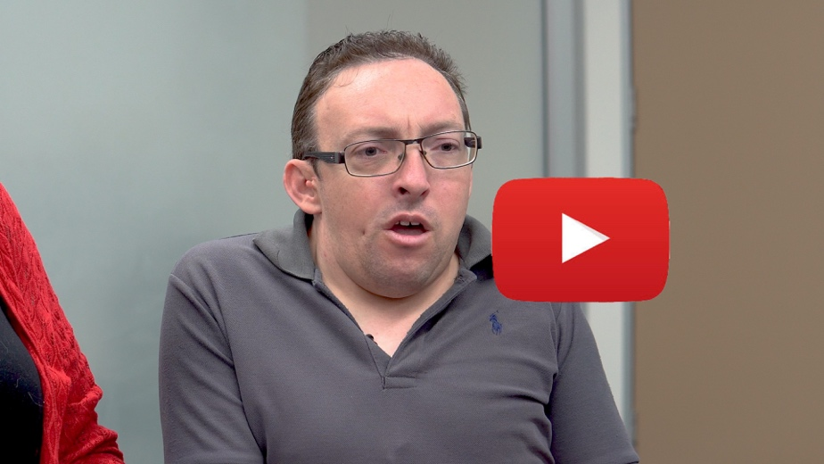
Video Transcript

‘Nothing about us, without us’

As Dave said, this catch cry is increasingly being used by the disability community. Central to this idea is that the people most concerned about an issue (in our case the lack of citizenship and basic human rights afforded to people with disability) are at the heart of the issue.

‘Nothing about us, without us’ resonates with many people because:

“If we have learned one thing from the civil rights movement in the US, it’s that when others speak for us, you lose.”
(Diane Drigger: The Last Civil Rights Movement: Disabled Peoples’ International. New York: St. Martin’s Press 1989, p. 28)

As you will see in the last topic of this toolkit, ‘nothing about us without us’ is also at the heart of co-design, where the people impacted most by an issue are the people at the centre of designing solutions.

To learn more:

Check out this video called ‘Nothing about us without us’ which was made by peers from some of the partner organisations involved in this project as well as others.

If you type ‘nothing about us without us’ into your search engine and look for videos, there are some great resources, such as this one: a global perspective of women with disability:

The expertise of people with lived experience

The second critical element Suzy identified is the idea of people with lived experience being experts. We will talk a bit more about this in the co-design section, but, as it is such an important principle, we want to talk about it here from specifically a human rights or self-determination perspective.
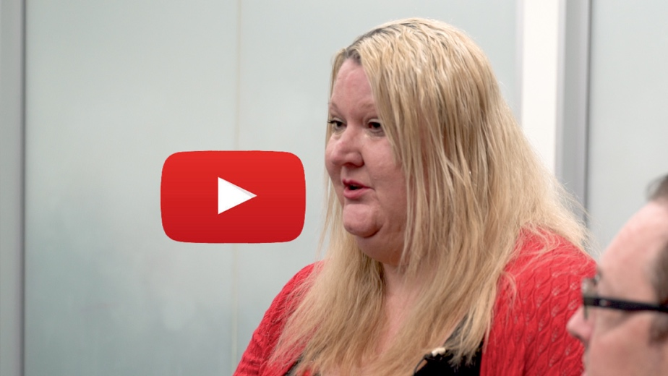

Video Transcript

From a peer perspective, the advice and support provided by a peer, an expert like yourself, with similar lived experience is invaluable and lives alongside advice and support provided by other experts such as people trained in certain disciplines or knowledgeable in certain topics.
Check out this video to learn more about peer support. Made by some of the TnT project partners to better understand what peer support is, what it does and why people with disability might be involved in in.
If that sparked your interest, check out this page for more videos on peer support

In Australia, it is probably the community of people with lived experience of mental illness who have most experience in working alongside governments and organisations to improve outcomes for the community.

The NSW Mental Health Commission and people with lived experience of mental illness co-designed the “Lived Experience Framework for NSW” (pdf only). This is a great resource especially if you want to understand some of the systemic, broader thinking.

The guiding principles referred to in that framework are worth reading and thinking about, as they require cultural and practices shifts for most agencies and individuals:

- trust the expertise and lived experience of people with mental health issues and caring, families and kinship groups
- respectfully apply and embed lived experience skills, information and insights
- develop a ‘safe’ space for dialogue and respectful inclusion of people with lived experience and caring, families and kinship groups and continued learning
- allow for ongoing capacity building of all participants (awareness and skills to change culture)
- work to challenge the status quo regarding mindsets, values, culture and current work practices
- develop a response with a structured and phased implementation (embedding) process
- create or adopt existing practical tools for change and provide support and training
- commit to ongoing collaborative engagement through co-leadership, co-design, co-creation, co-production, evaluation and shared accountability across the system.

From the perspective of an organisation such as NSW Fair Trading wanting to work with a community, the expertise and knowledge that people who have lived experience bring to any initiative is invaluable.

Dave and Suzy have some ideas and tips you might want to consider when it comes to working alongside peers.

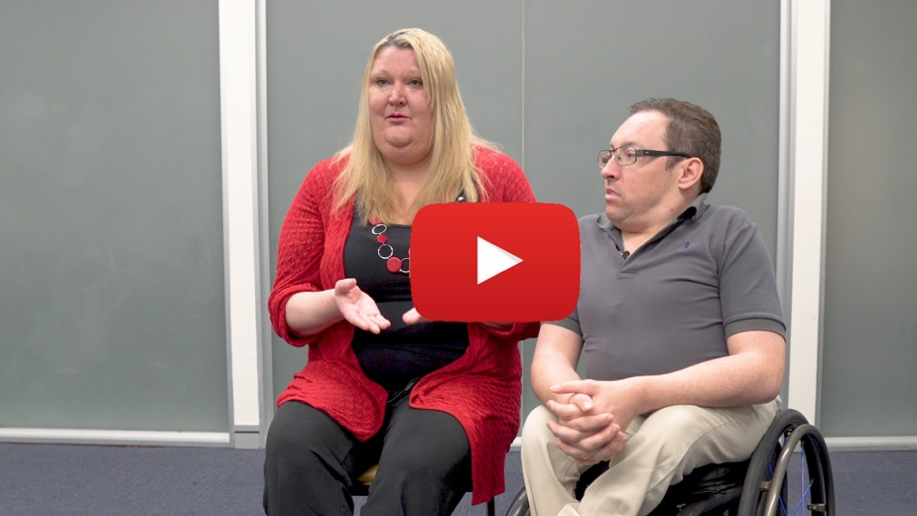
Video Transcript

The tips from Suzy and Dave include:

- Listen (more on that below)
- Don't assume (what people can and can’t do)
- Pay us for our expertise (talk to your HR people or get some advice on how to pay peers. In the TnT project, peers became employees employed by the different partner organisations. That employment was subject to the award the organisations operate under. For the production of the videos, peers were contractors and paid as suppliers. It can be complicated, so check out this ATO website for more info
- Know the difference between getting input from a peer or from a peer led organisation: There is no underestimating the power of tapping into the expertise that comes from lived experience. But the input from only one peer means that whatever you do is based on one person’s experience. If you want to create something that is more reflective and responsive to more people, you’re best to work alongside more people and also very importantly a diversity of people (more of that in the co-design section).

Equally valuable and important is the experience and expertise a project partner like NSW Fair Trading brings to the different communities. One of the things we have learned along the way is that each partner has to bring their expertise to the project and be valued for that expertise and experiences.

Please watch this video of the NSW Fair Trading staff, on what working alongside peers has meant to them and how it impacted on their work.

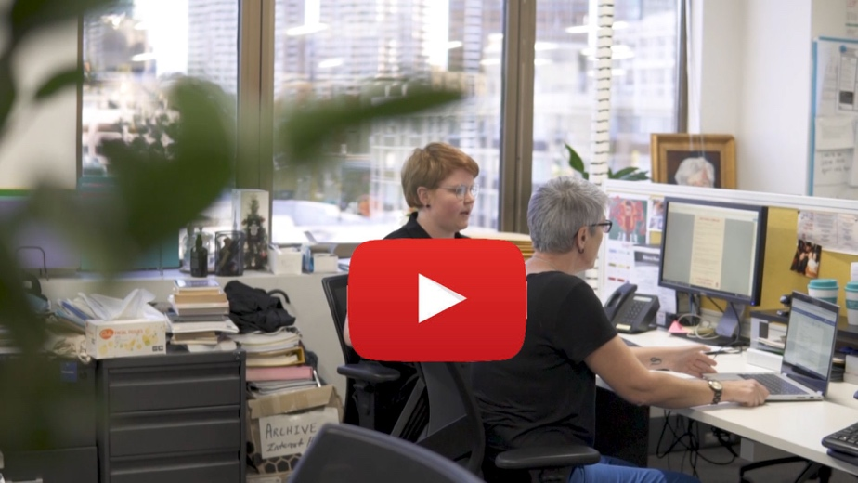
Video Transcript

The NSW Fair Trading staff (as well as Suzy and Dave) highlighted to importance of listening, so let’s have a bit more of a look at it.

Listening

We have all heard of active listening and we are all probably trying that one out, but what Angela is describing in the video is beyond active listening. Angela, who works in Broken Hill, says:

“I can’t even word it. But I know there’s a difference between how I listened and how I listen now. As I said, I listened before and I wrote. Now, I listen, and feel it. I think that’s where the difference comes in.”

And while Angela might not be able to put words to it, there are people who can. Maybe what Angela is trying to describe does not have a word in the English language, but it might be something the Indigenous people of the Daily River region in the Northern Territory call ‘dadirri”. It is a “deep listening, a listening that comes from still awareness”.

Or it might be called ‘ngara’ an Eora language term meaning ‘to hear, to listen and to self-reflect and to finish off what has been heard with an action.’

So this kind of listening e means having an obligation to do something with what has been told. This implies a connection, a reciprocity and an obligation by the listener to the speaker. It builds relationship and it’s this kind of listening that is most appropriate to working alongside peers.

To learn more about this listen to / read an ABC “All in the Mind” podcast on “Deep Listening” (The part on deep listening specifically is about half way through the podcast/ transcript).

Check out this beautiful video about the notion of ‘dadirri’:

The NSW Fair Trading staff also talked about opportunities to learn, and in the final section we will come back to learning as one of the key elements of successful co-design.

Topic 3: Co-design

You have engaged with your community and connected with some peers. Now the process of co-design can begin.

In the next video, Suzy and Dave, our TnT Toolkit guides, are introducing the final topic.

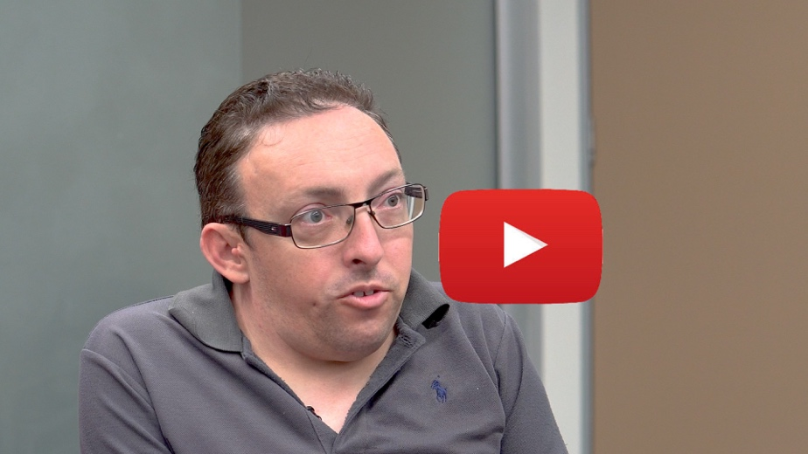
Video Transcript

Co-design in action

As part of the TnT Digital stories project (making loads of digital resources on Australian consumer law for the communities – see below) we produced some videos for the Deaf community.

Check out Hayley, Chrissy and Andrew talking about what is was like when they were asked to participate in a workshop to co-design video resources on Consumer Law for the Deaf community. You will also meet Genevieve, our Deaf community liaison. She was there to make sure that the film makers were aware of and did not miss critical Deaf culture and language issues.
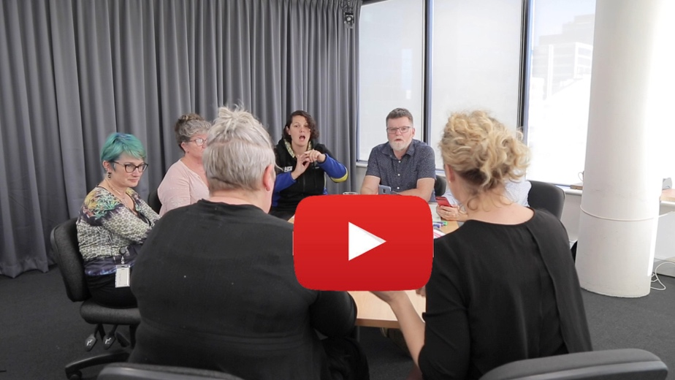

Video Transcript

From this video you get a few things that are really important to understand about co-design, right from the start:

- For co-design to work we have to connect more deeply and listen carefully to the nuances: Listen carefully to what Andres has to say:

“I think Deaf people miss out on all that contextual information. Like, going to the shop and if a person from the general society makes a complaint …. You can overhear that information and learn how to negotiate .. . [As a Deaf person] you don’t learn that stuff. “

- You have to let go of your assumptions and preconceived ideas. Genevieve says:

“The barriers are not just physical. They’re not just like, “I can’t access that information”. I actually think differently. My world view is different”

- Creating a sense of people being equal, having expertise and being able to contribute is critical. Hayley signs:
“I felt like, it mattered. I felt I contributed, I felt I could share. Like equals.”

- Keeping it real and authentic is also critical. Chrissie reminds us:

“Here it was fantastic, to be able to talk about those real life things”.

If you are interested in watching the results of this co-design workshop, check out the Talkin’ Together Auslan videos here.

Using a framework

We found that using a framework was quite useful in understanding the different steps involved in doing co-design and making sure we covered everything we needed to do. We used this framework:

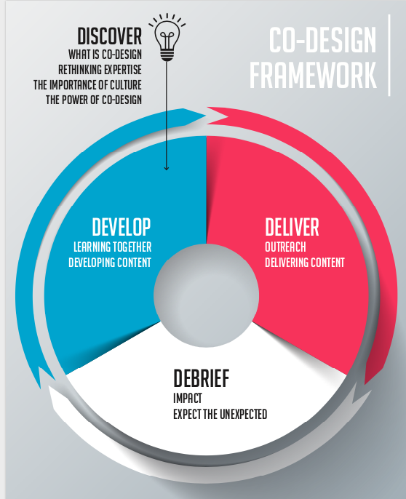

Discover, Develop, Deliver and Debrief (PDF only)

If you are interested in different frameworks and ways of looking at co-design, there are plenty of resources (just type co-design in your search engine).

You might like to check out this great co-design toolkit developed in Western Australia. It is based on other toolkits and co-design resources and focuses specifically on people with disability (pdf only)

To assist you in understanding each element of the co-design framework and how it worked for us in the TnT project, we now work through each one of those elements. We also have some videos involving the peers and NSW Fair Trading staff talking about their experiences and what they have learned.

Co-design 01: Discover

We have already talked about the importance of engaging with communities (Topic 1) and working alongside peers (Topic 2). The first element of co-design, Discover, builds on that learning and expands our thinking.

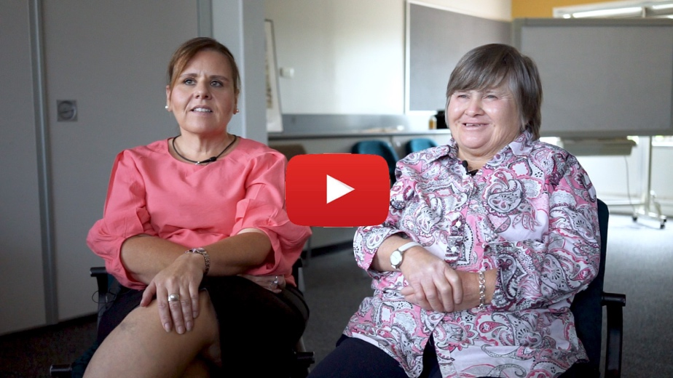

Video Transcript

What is co-design?

It’s always useful to start with creating a shared understanding of what co-design actually is.

Here are some quotes from the TnT evaluation about what we thought about co-design:

“I was quite unsure what it was going to involve (Peer Facilitator)”

“People and groups with different bodies of knowledge coming together and using this as a basis for developing something new. [Partner organisation]”

“I sort of [understood]…co-design is working together and making something and talking about it…. [Peer facilitator]”

In the video you hear people talking about, not so much a definition, but ways of being and acting that seem to reflect what co-design means to people. There are three key themes:
- people being equal,
- people being on the same page, and
- people learning together.

For a more ‘academic’ definition of co-design:

“Co-design is about engaging consumers and users of products and services in the design process, with the idea that this will ultimately lead to improvements and innovation.”

This definition is from a Booklet “An Introduction to Co-design” by Dr Ingrid Burkett. We think this is a great resource for anyone who is thinking about doing co-design.
“An Introduction to Co-design” by Dr Ingrid Burkett (pdf only)

When we talk about co-design we are not just talking about a one-off event, we are talking about a process, as well as a set of principles, including being:

“Inclusive – Representatives from critical stakeholder groups are involved in the co-design project, from framing the issue to developing and testing solutions.

Respectful – All participants are seen as experts and their input is valued and has equal standing. Co-design requires everyone to negotiate personal and practical understandings at the expense of differences.

Participative – The process itself is open, empathetic and responsive. All participants are responsible for the effectiveness of the process.

Iterative – Ideas and solutions are continually tested and evaluated with the participants.

Outcome focused – The process can be used to create, redesign or evaluate services, systems or products.
(Modified from NCOSS Fair Deal Forum; 11/2016)

And if that is a bit too dry for you, why not have a look at this short video from the UK?

The Story of Co-design

Rethinking expertise

One of the themes that has already been discussed is the importance of working with people who have lived experience. People are the experts because of their lived experience and great co-design means that people bring that expertise to the table.

Kellie, one of the peers, says:
“I do think my expertise contributed. Because, I have life skills. Life skills of somebody who has mental health issues, life skills of somebody who lives in a small community.”

For co-design to work, the people with lived experiences from the communities are critical. In our project the people with disability from different communities brought their expertise, not only as people with disability, but also as Aboriginal people, as women, as people living in rural and remote communities, as men, people with mental health issues and as gender diverse people. This of course also applied to the NSW Fair Trading staff, who also brought their expertise in Consumer Law.

Everyone valuing and bringing to the table their different expertise made this project stronger, more authentic and much more impactful then it would have been otherwise.

If you are interested in reading more about the benefits of bringing lived experience to the forth, check out ‘The Lived experience’

The importance of culture

In the video, Kellie talks about the culture in Broken Hill and how the TnT project brought in ‘away people’ by working alongside locals. Suzy and Tania talk about ways of connecting with Aboriginal people, where trust in government is a particular issue; and Liam is mindful of working cross-culturally with communities that do not speak his language.

Culture in its broadest definition, is:

“a fuzzy set of basic assumptions and values, orientations to life, beliefs, policies, procedures and behavioural conventions that are shared by a group of people, and that influence (but do not determine) each member’s behaviour and his/her interpretations of the ‘meaning’ of other people’s behaviour.”
(Spencer-Oatey, H. (2008):3 in: “Culturally Speaking. Culture, Communication and Politeness Theory. 2nd edition. London: Continuum.)

Reflecting that broad understanding of culture in the co-design process is critical. Acknowledging and bringing in cultural differences means better outcomes for diverse communities.

Another useful way to think about this is to consider the concept of intersectionality, which is a way of understanding multiple, overlapping social identities and forms of inequality.
Watch Kimberlé Crenshaw talk about intersectionality.

Seeing your project through the lens of intersectionality might be useful in your co-design work. It is about understanding that the people who are co-designing together have experiences that are different from one another because of the overlap of disability, genders, race, sexual orientation, class, ethnicity, geography etc. Rather than denying those different experiences, great co-design values and builds on them.

If you are interested in learning more about this, a one hour long video clip from ‘all about women 2018’ from the Sydney Opera House on “Disability and intersectional feminism”

The Power of Co-design

In the video Dave says it all:

“Co-design is a really important feature of this program. I think it should be something that should be fostered when government and disability organisations, are working together. You just get better results.”

This brings us to the end of the discovery phase of the co-design framework.

Check out the Discover worksheet and apply it to the project, program or initiative you are thinking about co-designing.

Discover worksheet

Co-design 02: Develop

In this second part of the co-design process we focus on developing new content by working together and learning from each other.

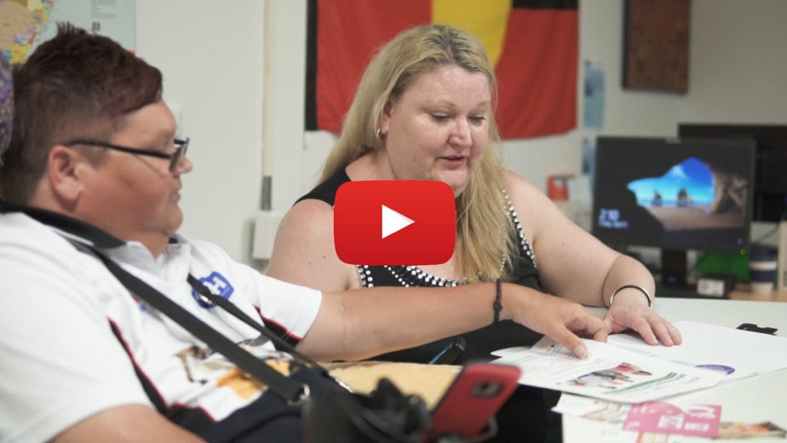

Video Transcript

Learning together

In the video you can see people engaging with each other and learning from each other.
- How could we make the content work for people with mental health issues?
- Working cross culturally, what does this mean when we talk about individual consumer rights?
- Knowing that people are fearful of government controlling people’s lives, how can we talk about going to ask for help?

One way to learn together is to make sure we speak about those issues that are more difficult to speak about, the issues that are often ignored or swept under the carpet. This is why the previous Discovery element is so important: it’s about building deeper relationships and trust so that you can have those conversations. As you watch the videos, the theme of trust and of building deeper relationships pops up quite a bit.

Once we move into developing the framework, it’s important to keep thinking about the relationships alongside our focus on the content.

To remind us, here are 7 Tips to build trusting relationships:

- Say what you mean and mean what you say.
- Be vulnerable — gradually.
- Remember the role of respect
- Give the benefit of the doubt.
- Express your feelings functionally, especially when it's tough.
- Take a risk together.
- Be willing to give as well as receive.
(from A. Bonior 7 ways to build trust in a relationship; Psychology Today; 12/2018):
Here the whole article about building trust in relationships

In the video you can see how Belinda and Leonie work together in a trusting way. Both were stretched by the other, open to learning more and opening up to new ideas. Belinda is really clear that she learned a lot from Leonie about how to make things work for people with intellectual disability. Belinda will be much more aware of people with intellectual disability in the future and, for sure, she will be much better in communicating and connecting with people.

Learning together can occur in many different forms, but it seems we do learn better from each other, if we are meaningfully connected and if we have positive regard for each other.

If you are interested have a read of the article about learning more on how to accelerate learning from each other, either in co-design or when working with your colleagues.

Developing content

People from the different communities talked about their experiences and the strength that comes from telling real stories. It’s a theme that was repeated throughout the TnT project and as trust developed between the communities and the Government partner, more people felt comfortable sharing their stories and experiences.

In the TnT project we developed a whole host of new content:
- workshops presentations,
- promotion materials,
- new content,
- role plays, and
- we told stories.

One of the stories we told is of how Kellie negotiated a new contract with a new service provider, a local gym.

Have a look at this video with Kellie, telling her TnT story about contracts

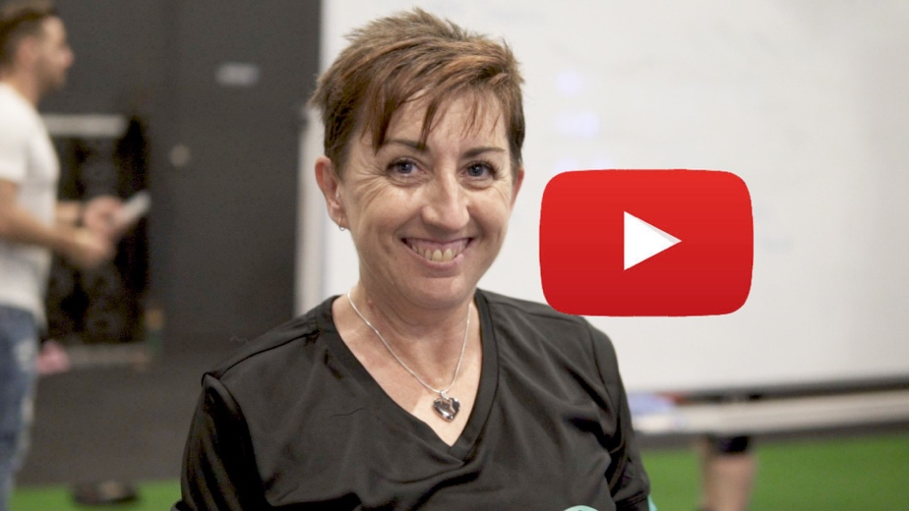

Video Transcript
Watch the other 3 stories and 4 top tips videos we developed for Talkin’ Together

Focusing on developing new content by working together and learning from each other as we engage in the content is sometimes referred to as co-production.
To learn more about co-production, check out the Scottish Co-production Network website for loads of resources and some videos.

From the independent evaluation, we learned that when it comes to co-production, people said what worked was:

- Strong relationships between project officers, peer facilitators and NSW Fair Trading co-facilitators on the ground
- Having people with the right attitude
- People being open to listening and learning
- People being open to trying new things
- Having everyone involved from the beginning
- Having regular communication.
- Some people also liked starting without a structure for the process
If you are interested in some more about co-production and what we did and worked for us, check out Co-production - the process
And also some Tips from CID on co-productions

Worksheet Co-design: Develop

Co-design 03: Delivery

The third part of the co-design process is about delivery. We focused on two topics:

- outreach, and
- the delivery of content.

Video Transcript

Outreach
Our outreach examples focused on community radio and the use of social media. Kellie and the team in Broken Hill got the word out through their local community radio station.

Tania and Suzy used their social media profiles and links to peers to promote consumer law messages.

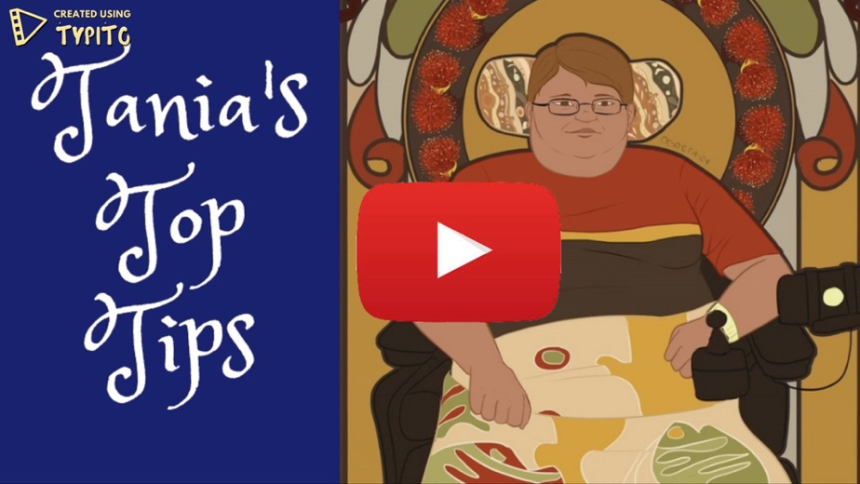

Video Transcript

This is one of several videos Tania made building on some of the key TnT messages. Some of her videos went viral on Facebook.
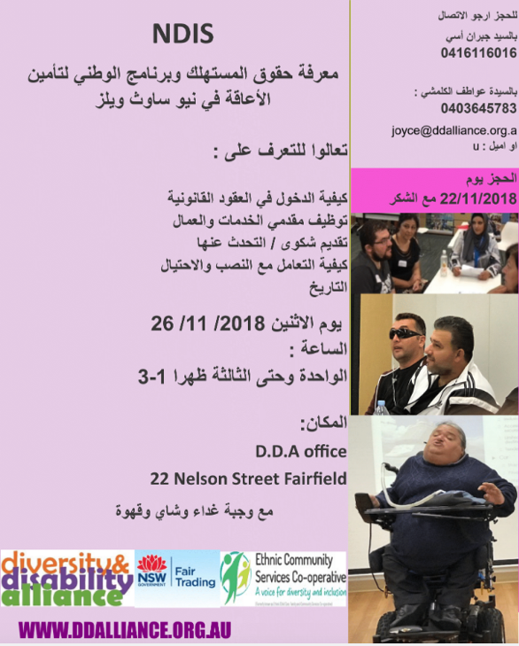
Other community outreach strategies used by the partners included linking through disability service providers, outreach through ethno-specific groups, community cultural events, utilising existing peer networks and more.

Here a photo of a flyer produced by Diversity and Disability Alliance about a TnT Workshop that went out to Arabic speaking communities.

Outreach becomes much easier if you have really connected with your community, and you have peers involved.

If you are struggling getting the message out to the target community, maybe you are not as connected as you’d like to be. Why don't you go back to Topic 1 (Engage with Community) of this toolkit and have a look at the messages and ideas there?

Delivering Content

When it comes to delivering content, the peers really came into their own. Their creativity and inventiveness brought the material alive and made it relatable.

At TnT each of the community partners did things slightly differently.

To read more about this check out this document from the independent evaluation about the different design and delivery models

However, despite the differences in delivery, in the overall independent evaluation, similar strengths were reported:

- Face-to-face workshops supported engagement, interaction, sharing, questions and clarification of information, and understanding, in a way that online information would not
- Participants generally found information easy to understand
- Participants were engaged and asked questions
- Co-facilitators built rapport with participants, so people felt comfortable to share
- Peer facilitators helped participants feel connected and more engaged in the messages
- Peer facilitators helped build trust with participants – “the guards went down”
- Peer facilitators’ stories about their own experiences made the content relatable and helped spark discussion
- Role plays and other interactive activities made workshops engaging and helped make information understandable.

In the video you hear from the folks who attend a program run by Mission Australia in Broken Hill. They came to some of the workshops delivered by the peers from Being and Angela, the local NSW Fair Trading staff member. They said:

“It was really informative because I learnt a lot, you know.”
“I knew of some rights but not all of them.”
“Alicia and Kelly, yes, you can relate to them more, because they've been where you have been.”

It’s clear that who was involved in delivering the content (peers) was as important as how the content was delivered.
A photo from the power point used by Diversity and Disability Alliance to get the message about scams across to people from diverse cultural communities.

In the section on engaging with communities we talked about the power of language, mostly in the context of using inclusive language and checking out with communities what terminologies they prefer.

At TnT, in terms of delivering the content, the message was pretty clear: It’s all about easy read / plain English. Jargon, if it is used at all, needs to explained right from the start.

The use of easy read / plain English doesn't just work better for people with cognitive disability. It works better for everyone. (Apparently 40% of Australians have literacy levels below what is considered necessary to get by in everyday life; Australian Bureau of Statistics, 2013.)

To get on top of this and start thinking creatively, check out this more info on easy read from The Information Access Group

And if you are thinking that easy read / plain English is easy to speak and write, why don't you have a go at this government document and see what you can do?

Standard 1 of National Disability Standards

How would you go about using an easy read / plain English approach to this first standard?

Have a look at this easy read / plain English version of the above document (pdf only)

In the TnT project we also worked together and created new written resources, making those resources work for the communities they were intended for. Have a look at some of the different resources developed for this project.

Here a photo of the peers from Being, one of the partner organisations, with some of the merchandise they developed to give away.

And here’s another photo of some of the specific resources they developed together with NSW Fair Trading staff.

And of course, as you can imagine, there was a lot of creativity in getting the messages across in the workshops. Games and role play really helped.

Have a look at this video of a role play developed by the peers from Being, highlighting the sensitive topic of “Romance scams”.

Video Transcript

When we talked to Steve about this roleplay, he said that it got people laughing, yet it also got them talking about loneliness and being vulnerable. It really got to the heart of the matter.

Worksheet Co-design: Deliver

Co-design 04: Debrief

Once you have discovered, developed and delivered, you want to make sure you debrief. You want to make sure you check that you’ve met the mark and had maximum impact.
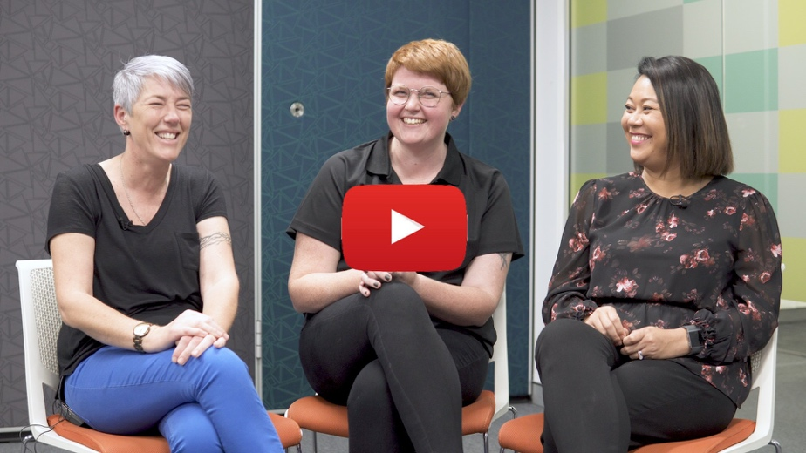
Video Transcript

In this last video we bring together some final elements of co-design.

Debrief

You can hear Simon, Deb, Angela and others talk about debriefing after the workshop, reflecting on what worked and what did not work, and making changes.

What they are doing might be called ‘reflective debriefing’: Everyone worked together delivering the content and then, afterwards, thinking back on what happened, they all shared their thoughts with one another, offered suggestions and made changes so it could work better next time. This was another critical part of the co-design process.

You might have thought that the debriefing at TnT was a bit ad hoc and fluid. If you’re interested in ideas for a more structured approach, we would recommend you also download and read an excerpt from: “Reflective Practice – why different points of view matter”, which provides insights into the power of reflection, as well as techniques and practices that you can use for your debriefing.
Excerpt from “Reflective Practice- why different points of view matter”

Impact

We are almost at the end of the toolkit and we would like to share a bit more about the impact the project had. Earlier we heard from the people at Mission Australia in Broken Hill and what they got out of the project.
Read more about the impact we made on the people who came to the workshops

In Topic 2 (Working alongside peers) we heard from NSW Fair Trading Staff about the impact this project had on them and on their work beyond the TnT project. Here are some more highlights about the benefits of the process, from the evaluation:

- Breaking down barriers between people with disability and Fair Trading
- More knowledge and understanding of the lives of people with disability and how to engage with individuals with disability
- Increased capacity to tailor how information is communicated to people with different types of disability and from different cultural backgrounds
- Increased understanding of the barriers people with disability face and how Fair Trading information, website and processes can be more accessible
- Increased experience in co-design and understanding of the value of learning from people with lived experience
- Improved co-facilitation approaches –including flexibility with ways of delivering content –and understanding of the value or peer delivery
- Strong relationships with peer facilitators.

And of course, the TnT project had a significant impact on the peers. Over the life of the project there were 13 peers involved.

In this last video, peers took the opportunity to speak about the impact:

“The best thing was learning new skills and being with other people and having an income.”
(Leonie)

“This is the first job in my life, in Australia, that I work. My English get better, and confident to read and speak louder and I can share my own story.”
(Sophon)

“I think I’m more confident than I would have been 2 years ago and, I even made a complaint, a couple of weeks ago.”
(Suzy)

“I did adapt through my personal experiences. I’m not shy anymore. It’s all about being proactive and adapting.”
(Liam)

“The thing that was good about the NSW Fair Trading project was I get more confidence. And now talking to people, new people, I am not afraid, I am happy to do.”
(Grace)

The evaluation of TnT captured some more of the impact for peer facilitators, including:

- Improved knowledge of consumer rights that they can share with peers or in their work, including how to review a contract
- Increased confidence to stand up for themselves if they felt something was wrong with a service provider
- Increased skills in facilitation; storytelling; presenting information and advocating
- Improved ability to work in a team –to support each other, resolve issues and hold people to account for commitments
- Increased professional skills and, in some cases, ongoing employment opportunities
- Increased understanding of community and community connections, including long-term connections to peers, confidence to participate in the community, and confidence to offer support and advice
- Being seen as leaders in their community
- How rewarding it is to be able to teach peers about their rights.

Expect the unexpected

The final topic is really simply to point out that with co-design you must expect the unexpected. With any project, program or initiative there are elements and outcomes that are unexpected. Once you engage in the process of co-design, the unexpected is almost guaranteed – and is in the unexpected that some of the ‘gold’ of co-design can be found.

In line with this we finish off this toolkit by quoting Oscar Wilde:

“To expect the unexpected shows a thoroughly modern intellect.”
(Oscar Wilde: The Ideal Husband, 1895)

Co-design appears as a thoroughly modern process to create initiatives, programs, policies and responses to creating more inclusive, welcoming communities in the 21st century.

Should you co-design?

Let’s go back one last time to Suzy and Dave, who finish us off with some of the benefits of co- design.

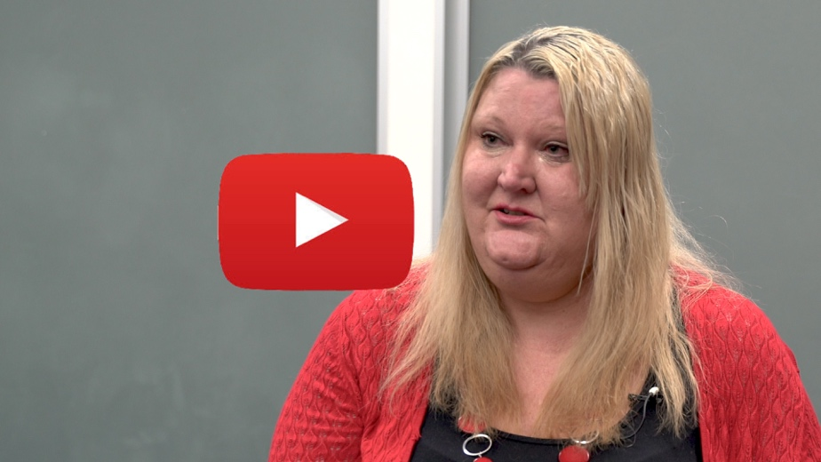

Video Transcript

Thank you for checking out this toolkit. Suzy says, give co-design a go; and as Dave says,
“it provides better outcomes and it does make the world more inclusive cause you are acknowledging and trusting different people with different voices to know what they need and helping them deliver those outcomes.”

Thank you

Before we finish, we want to thank:
- All the Peers who participated in the project and in the making of all the resources
- The partner organisations who collaborated with NSW Fair Trading:
  - Being NSW
  - Community Disability Alliance Hunter
  - Diversity and Disability Alliance
  - Ethnic Community Service Cooperative
  - NSW Council for Intellectual Disability
- Deaf Society NSW for their assistance in codesigning the Auslan resources

This video has been produced by NSW Fair Trading with funding support by the NDIS through the Information, Linkages and Capacity Building (ILC) – ILC National Readiness Grants.

Feedback

Please, if you have any feedback, let us know by emailing NSW Fair Trading on: Clc_disabilities@customerservice.nsw.gov.au

Disclaimer
The Talkin’ Together videos and toolkit have been produced as part of a community project.

You must not infer endorsement by the NSW Government of any person, organisation, goods or services.

Attachments
- Transcript: Promo
- About Tnt
- Transcript: Welcome
- Transcript: Why engage?
- Transcript: Nothing about us without us
- Transcript: Lived Experience
- Transcript: Tips for working alongside peers
- Transcript: Working alongside peers
- Transcript: Co-design
- Transcript: Co-design in action
- Transcript: Co-design – Discover
- Discover Worksheet
- Transcript: Co-design – Develop
- Accelerate Learning
- Transcript: Kellie
- Co-Production the process
- Tips from CID
- Develop Worksheet
- Transcript: Co-design – Deliver
- Transcript: Tania’s Tuesday Tips
- Excerpt from independent evaluation
- Standard 1
- Transcript: Romance scam
- Deliver Worksheet
- Transcript: Co-design – Debrief
- Reflective Practice
- Impact excerpt from evaluation
- Transcript: The benefits of co-design

Attachments:

- Transcript: Promo
Fair Trading New South Wales
partnered with peers and community organisations
on Talkin' Together,
a co-design project to educate people
with disability about Consumer Law.

We brought our lived experiences
and expertise to the project,
teaching Fair Trading how to better connect
and communicate with communities.

Together we ran workshops
and created video and resources
about Consumer Law and
the process of co-design

Check it out

- About the TnT project

The transition to the NDIS has brought many more consumers with disabilities into the marketplace. Many of these consumers do not have experience in the purchasing services or entering contracts, as the government has previously managed many of the services and purchases on behalf of people with disabilities.

NSW Fair Trading’s Consumer Awareness Protection Initiative (CAPI) project in 2017/2018 engaged with nearly 12,500 people across NSW to increase awareness of Australian Consumer Law (ACL). The project identified that some cohorts of people with disabilities are less familiar / confident with making a complaint. Consumer protection agencies are concerned that without complaints the true nature of issues are not being identified and addressed early, as they do not have sufficient data. A range of barriers to people with disabilities understanding their rights and using those rights to make a complaint has been identified, creating an opportunity to engage with priority communities in targeted ways to increase awareness and confidence.

Creating trusted sources of information and support is integral to building people’s capacity to exercise rights in the marketplace. Feedback has been received from communities that they would like to hear the voices of people with lived experience of disability talk about their experience of purchasing from the market, as well as engage with Fair Trading staff talking about complaints from their perspective.

The Consumer Awareness Peer to Peer (CAPP) project was developed based on our learning from the CAPI project including:
- People with disabilities want to hear about the experiences of people with disabilities when exercising their rights. Their experience is really valuable to enable others with similar disabilities to learn and engage with their rights.
- Culture has really significant impacts on the way we engage. We want to explore better ways of building trust and engagement opportunities with our Aboriginal and multicultural communities.
- People with mental illness are hard to reach and hard to engage with because we don’t have the necessary relationships of trust.
- Aboriginal people with disability want to engage with other Aboriginal people with disability, not just other people with disability. Culture is more important than disability.
- We need to work with partner organisations who have relationships of trust if we want to build the capacity of people with disabilities to exercise their Australian Consumer Rights
The CAPP project took on the name ‘Talkin Together’ and addressed these objectives through developing opportunities to co-facilitate community engagement with people with disabilities.

Partnerships were developed with key organisations that support people with disabilities to exercise their rights including:
- BEING (previously NSW Mental Health Awareness Consumer Advisory Group),
- Community Disability Alliance Hunter (CDAH),
- Diversity and Disability Alliance (DDA),
- Ethnic Community Services Co-operative,
- NSW Council of Intellectual Disability (NSW CID),
Using a co-facilitator model creates a source of trust and shared expertise – deliverable in a variety of communities and able to occur reasonably quickly in a decentralised way because of acknowledgement of different knowledge and expertise. This will gradually build the capacity of the individuals and support organisations to build capacity with ACL, while developing a transferrable framework of resources and supports for other organisations to implement after the project ceases.

Research and experience from organisations such as CDAH has shown that support from peers is highly effective. People who have lived experience of disability can offer invaluable support to others who are on a similar journey. For people with a disability and their families, peer support can be a powerful and effective form of getting information and assistance. People are often more comfortable sharing knowledge, ideas and experiences with their peers through natural, informal conversations, rather than engaging formally with service providers and government.

Creating behavioural change within communities is time consuming and requires a high level of trust to be established between the organisations. This is time and labour intensive. This is a sector significantly impacted by the reforms to the disability sector and is experiencing conflicting norms of behaviour as the sector moves from welfare to the marketplace.

The Talkin’ Together project:

- Utilised expertise of people with disabilities to talk about their experiences of NDIS (or the market) when entering contracts, hiring services or using complaints processes
- Used the expertise of Fair Trading staff to talk about Australian Consumer Law
- Adopted a model of co-delivered facilitated conversations within local communities at the proposed trial sites using the shared expertise of people with disabilities and Fair Trading staff.
- Worked collaboratively with the key partner organisations to deliver a co-facilitated community engagement strategy in identified areas.
- Transcript: Welcome
Welcome to the Talkin' Together toolkit
I am Suzy Trindall and this is Dave...
Belcher?
Yes [laughs]
I am a peer worker at CDAH
and I have been working on the TnT Project
I'm also Aboriginal Woman
I was born on Gadigal country, grew up on Darug country,
both part of the Eora nation
and we are here to talk about
the Talkin' Together Toolkit

Thanks Suzy As Suzy said, hi my
name's Dave Belcher
I'm the Executive Officer at CDAH
There will be three parts to the Toolkit:
Engage with community
Work alongside peers
and Co-design

- Transcript: Why engage?
When we started creating the idea of this,
we were coming off the back of a
previous project that had been teaching
people about their rights

As people started to learn about their rights
we realised how very important it was
not just to tell people the information
but to include people in the way we provide it
It became evident that some communities needed
more information in more specific ways
and the only way to find that out was to ask
Rather than tell, we wanted to go out and ask
the communities so, if you look,
we're talking to people with intellectual disability
people with psychosocial disabilities
people with disabilities from the multicultural community
and people with disabilities from the Aboriginal communities
and there's really specific communication needs
and cultural components to each of those groups

At the beginning of the project
we didn't know the disability sector
We needed to learn that and we needed
that shared to us in ways that we could access it;
and, similarly, we didn't expect people to
know Australian Consumer Law
but we needed to know how to share it accessibly

And that was really interesting,
and I think that that was part of why it was
hard work, right at the beginning

Anyone who buys, sells, rents, hires in NSW is going to
use the laws that NSW Fair Trading is responsible for

We are a mainstream agency. This is an agency that has
fairness at its heart.
We're there for everyone

If a mainstream agency can communicate well
and teach rights that prevents harm
and if we can do it in a co-design way
with other agencies that know
how to introduce us and engage us
with that specific community
we're going to do it well

- Transcript: Nothing about us without us
Welcome to Part 2 of the Talkin' Together toolkit
This is about working alongside peers
and there are two really important parts to this
and the first one is
'nothing about us without us'
and the second is lived experience

So 'nothing about us without us',
it's a phrase that get's used
increasingly within the disability community

So 'nothing about us without us'
refers to previous periods where
government policy or programs
were being developed for people with disability
without actually including us in the conversation

We strongly believe that the best results
will only come about
if we are included in the process
so it can't be separate from us

we have to be part of the solution

'Nothing about us without us'
means to me that
nobody's going to talk for me,
nobody's going to make decisions for me

We don't want government
talking for us, making decisions for us

- Transcript: Lived Experience
Yes, so I was really lucky enough
to be able to work with the Aboriginal community

It's really important as an Aboriginal woman
living with a disability, who has the lived
experience, to be able to go out into
my communities

It's incredibly important that
government utilise the skills of
people with disability
because we are the experts in our own lives

There is no other group that can bring
that level of expertise

So it's really important because
the stories that we share
impact people’s lives
and as a result
people then go and make changes

- Transcript: Tips for working alongside peers
So it's incredibly important that
people who work alongside people with disability
truly listen to what they're being told

I would say working alongside somebody with a disability
is to not make assumptions about their capability
and to definitely listen and not to speak on behalf of them

It's also really important that we got paid,
we got experience and for some
it was their first position held

So it should be also be acknowledged that
there is a real distinct difference between
engaging someone as a peer worker
and engaging a peer-led organisation
With peers they bring their own personal lived experience
which is incredibly powerful
The peer-led organisation brings a greater membership,
a greater level of experience and expertise

- Transcript: Working alongside peers
I think the TNT project has brought to the
forefront to me that things can be
done differently

I suppose the aim is to get government to
stop and listen long enough to what actually works
rather than take this broad-based,
one-size-fits all approach to messaging

We realised how very important it was
not just to tell people the information
but to include people in the way we provide it

So what we bring to you is how to avoid
getting ripped off
What you bring to us is the story of your community

Working in the government for 20+ years
you do get caught up to the point that
you don't realise how much you
communicate in a certain or set way

Coming into the project, I thought that
I was really good at communicating
I was a bit shocked to think I was,
you know, one of these people
who wasn't that good at listening

I can't even word it but I know
there's a difference with how I listened
and I listen now
as I said, I listened before and I wrote
Now, I listen and feel it

I think that's where the difference comes in
I walked in and I go “I have no idea how
this is going to go"

It changed me in a way that I am definitely more conscious
Of thinking about the people who's receiving our services
and to put them at the centre of what we do

For me, it's always remembering
to call out the voice of a person with a disability,
or any sort of consumer who doesn't just fit the box,
to be able to say "Have we thought about them?"
You know, "Have we gone out and asked them?
Why can't we do that?"

I think what people learned was the ability to take risks,
have some courage, because it pays off
And when we do that, and we say we don't
know things we have the opportunity to learn

- Transcript: Co-design
Welcome to the final topic and the topic is co-design

We all came together with the other groups
It was really amazing to hear what the
other groups were doing

Everyone was doing things differently
I took away quite a few things

Within co-design it's incredibly important
to have a diversity of voices

We actually went out to the Deaf community
and with them developed a short video
which we'll see now

- Transcript: Co-design in action
Well I meet a lot of Deaf people in the community
and the complaints and issues, they're unsatisfied with things
Deaf people miss out on all that contextual information,
like going to the shop and if a person from the general
society makes a complaint and, you know, challenges
you can overhear that information
and learn how to negotiate;
or learning how to sign a service agreement,
we don't learn that stuff

It's the system not fully understanding Deaf perspectives
and not including it so the barriers are
not just physical, they're not just:
'I can't access that information'
It's that I actually think differently,
my worldview is different,
the vehicle through which I express
that worldview is completely different

Before I got here today I was a bit nervous
thinking "What are we going to talk about
and what do I need to do?"
But when we started unpacking all the information
I didn't realise all the details and how much
this information is so important for the Deaf community

Here it was fantastic to be able to talk about
those real life things and it's all being filmed
Then it can be shared with the Deaf community
and they can say "Oh, actually that's
happened to me"

I think it was great to have a variety of
different ages, different experiences,
life experiences, to be able to share
that, for example, for me, working collaboratively
and in co-design processes with Deaf people,
it's important to understand that for inclusion
It's also a benefit to the whole world
to make sure that unique perspective
is actually brought to the table

I felt like it mattered, I felt I contributed,
I felt I could share like equals. I think it's so worthwhile

I've actually seen and experienced it myself
I'd love to encourage other Deaf people
to participate in this co-design process.

- Transcript: Co-design – Discover
Well I see co-design as being two equal partners coming together
I think it's marvellous there's no hierarchy, if that makes sense?
And our voices are equal and all valued

I would refer to Leonie as a co-facilitator

Yes, I did feel like an equal

We did try to create that alliance
making sure that we're not falling behind

We are on the same page

We were learning together from the very beginning

We became a great group not just as support worker
and peer facilitators but as a family. Almost

A lot of our Fair Trading project workers
felt that they were really ill-equipped
until they finally figured out
that meant they didn't come with any pre-determined
ideas on how things should be.

Yes I do think my expertise contributed
because I have life skills
Life skills of somebody who has mental health issues,
life skills of somebody who lives in a small community

When we first met, I don't know anything
Like, I walked in as an empty canvas
and I said “You gotta tell me,
what's gonna work?”

Broken Hill is such a close community
and we have this stigma of the 'away people'

So having locals with 'away people', it opened the doors
for them to come in

Most of the communities we have interacted with
are ethnic communities
where English is not their first language
We have to collaborate with the interpreters beforehand
so we need to take our time to
make sure our presentations are clear

We were going out to community
and trying to get the Fair Trading message across
Most mob are fearful of government
so, you know, they don't want
nothing to do with them
It's definitely about sharing stories,

So it was really important for
Tania and I to be really vulnerable
and talk about all our experiences,
both good and bad

You get people to open up and keep it as free
and easy as possible. No expectations.
Just come in and make connection with each other

Co-design is the process of inclusivity

Working in collaboration with other organisations,
Particularly with consumers, our whole ethos is
making sure consumer voices are heard
and peer voices are heard
so having consumer leadership and co-design
is a huge part of what our whole organisation is all about.

Co-design is a really important feature of this program
and I think it is something that should be fostered
when government and disability organisations
are working together- You just get better results

- Discover Worksheet
Topic | Key Questions | Ideas | Your Project- your actions
Principles  - Inclusive  - Respectful  - Participate  - Interactive  - Outcome-focused | - Who are the people at the centre of the issue/program/ initiative?  - Have we got contacts to those people?  - Do I understand the diversity of the people who are at the centre?  - Who is not in the conversation and how can we reach them?  - How will all people who are at the centre be included?  - What are we doing to show that people feel respected and valued?  - What can we do so people can participate in different ways?  - What agreements do we want in place right from the start?  - Will we have rules so we know how to engage with each other?  - How will we make sure the rules work for everyone?  - How will we share responsibility (and power)?  - How will we learn together? | - The invitation to the initial meeting included images of diverse peoples and was in easy read  - We made reminder calls before the meeting to people who asked for them  - We asked people if they needed interpreters or other supports at the meeting  - Everyone had a chance to speak – we used a talking stick so there were no interruptions  - We made the rules together, we wrote them down in easy read on big paper, and we went through them at every meeting  - Everyone in the room got paid for their time  - Everyone who wanted to has a chance to lead the meeting  - We made notes and they were available in different formats  - Sometimes we had big group talks sometimes we broke up into smaller groups  - We took time to agree and make sure everyone had a say if they wanted to  - We took regular breaks  - We made sure we had time, so people got to know each other
Rethinking expertise
- People with lived experience are at the centre

Remember the importance of culture
- Think intersectionality

- Transcript: Co-design – Develop

We asked lots of questions, didn't we?
Like, we kind of - I think it was
a bit of discovery in the beginning

We got together here at the office
and we just had a talk around the table
how I would like it to be presented
because everyone learns differently
and reads things differently
and absorbs information differently

We did our workshops in getting to know each other
We talked about co-design and co-presenting
and how it would work

I thought it was good that I was able
to help Belinda because she said she didn't have
much understanding before
of people with intellectual disabilities

I guess I'd been within the government for so long
and I was so used to the jargon
that Leonie helped me break it down
and, like, make it accessible
for people with an intellectual disability

There was a lot of content to deliver from Fair Trading
and what we did with each presentation
as that we said “too much”
We cut it down
We brainstormed and talked a lot about
our experiences and which ones were
most effective to share with community
and that they would relate to

We added a lot of rawness, I think you'd say,
to the presentation
It was a very different process
to what would have been done by Fair Trading

Trust was something that was very important
from the beginning

We have to tell the truth, our own stories

That's where the real valuable information was
was in those personal stories.
But they didn't come out in the beginning
that was kind of more halfway along
more stories were coming out
and that was more a confidence and trust

We created a whole new suite of resources
based upon Fair Trading's previous resources
but by having our consumers make it,
having our peers design it in a way that they know
is going to land

As we were learning we had identified
that there were four subjects
for our workshops
Do you remember what they are Leonie?

Hiring a service,
Making a complaint,
Making a contract
and Scams

Yes

So what we did is we went through
each of those topics

So I showed them information
that New South Wales Fair Trading had,
or used, and Leonie was really good
with the easy read stuff
and, like,
she introduced -
I didn't know what she was talking about at first
Like, what's this 'Easy Read?'
What's this easy English stuff?
I don't know, what are you talking about?!

Another thing Leonie taught me
was that some people perhaps need visuals,
or need pictures and will learn more
So we did Powerpoint presentations
and they had pictures on them,
didn't they Leonie?

Yeah that was a better idea

- Accelerate Learning
We learn more when we learn together
By J Dutton and E. Heaphy; January 2016
https://hbr.org/2016/01/we-learn-more-when-we-learn-together#comment-section
We rarely grow alone. In fact, some psychologists have made a compelling case that we only grow in connection with others. However, we don’t need to learn with others in formal training or development programs: we can architect our own opportunities to gain insight, knowledge, and skills that move us on an upward trajectory. We can have more control over our learning at work if we make building high-quality connections a priority.
What are high-quality connections? They’re the connections with other people in which we feel positive regard, mutuality, and vitality. Positive regard is the sense that someone sees the best in us, even if we are only connected for a short time. Mutuality means we feel a sense of responsiveness and openness from another person. Finally, vitality captures the heightened sense of energy we feel when deeply connected to someone else — as if we are more alive in the moment.
High-quality connections are what Barbara Fredrickson calls micro moments of love. Don’t let the word “love” scare you. These moments of aliveness in connection with others create a sense of safety and enhanced capability that become a powerful platform for development. We grow in high-quality connections because our thinking is broadened, we absorb knowledge more quickly, our action repertoire is expanded, and we are more engaged, playful, open, and resilient in the face of setbacks. High-quality connections stand in stark contrast to low-quality connections, in which feelings of inadequacy, defensiveness, and lack of safety undercut growth possibilities.
Research conducted by us and by others shows that there are at least eight different ways we can grow and improve through high-quality connecting. Keep in mind that these tactics won’t work with lower-quality relationships.

- Create a lunchtime or after-hours working group with people from around your organization to watch educational talks or take an online course together. Support and constructively challenge each other to learn. For example, to build capacities for managing stress, watch a series of TED Talks that inspire and educate on successful strategies for stress reduction.
- Propose a self-managed instructional course for your team or work group, and share responsibility for designing and leading the various elements of the course. Staff at Jane’s business school designed a six-week course on positive leadership. Their personal involvement in the design and execution made it a success: Not only will the course be repeated next year, but it also opened up new staff-initiated learning opportunities. The group is now designing a certification training program to deliver the content of the positive leadership course to other staff on campus.
- Set learning goals for a specified time period, and invite one or two people to be your coaching partners to hold you accountable and cheer you on. In a consulting firm Emily studied, a partner and a project manager paired up to support each other’s growth. One person wanted to work on improving the skills needed for a promotion, and the other focused on efforts to create more work-life balance. Through regular, informal coaching sessions they were able to help each other reach their goals. The arrangement was so effective that they have continued with regular coaching sessions.
- Look for a challenge in your organization and create a task force or working group to tackle it, with the explicit goal of creating high-quality connections that will lead to learning and growth for all. At workforce solutions firm Kelly Services, two operational leaders saw a need to increase the leadership pipeline and employee engagement through strengthening network connections. In addition, they wanted to improve business acumen and understanding of the business among all leaders. They created a business resource group called “Leadership in Action” (LIA), composed of managers from multiple levels of the firm, and set up meetings, events, and webinars in which senior leaders provided insight into external market changes and how the company strategy addressed those changes. They used communication tools like Salesforce Chatter (an internal social network) to encourage discussion, and they shared articles on the company intranet. LIA has received very positive feedback: several members have moved into new leadership positions (including senior roles) and note their participation in the group as a key contributor to their success.

- Take on a shared experience with colleagues who are high-quality connections to explore and understand how work gets done with “fresh eyes.” For example, take a walk in your customers’ shoes. Theda Care, a five-hospital system in Appleton, Wisconsin, did exactly this when a team of employees became patients at the hospital as preparation for redesigning its critical service delivery system. The changes they recommended have contributed to substantial improvements in safety, efficiency, and effectiveness.
- Reenergize a group or task force you are currently part of by actively increasing the quality of connections. Encourage members to seek and provide help to each other. For instance, the leadership team behind the Broadway sensation Hamiltoncontinuously asked each other what they needed in order to shine while developing the show. Some members described the group space as “the most loving, creative gentle space that I’ve ever been a part of. Nothing was ‘wrong’; you could fall flat on your face and try again tomorrow.” In their case, this process helped to create a genre-defining hit musical.
- For employees who work remotely or have limited face-to-face contact, make an explicit effort to share stories in person about challenges and opportunities involved in doing the work. Numerous studies show that sharing stories is critical for facilitating the development of tacit knowledge, making sure questions are asked safely and frequently, and providing the opportunity for people doing similar work to share and strengthen their expertise. Chris Myers studied flight medical teams in several university hospitals and found that they regularly use lunch breaks to find each other and share case-based stories, which are vital to learning about new diagnoses and techniques.
- Stretch the boundaries of your work community beyond a common employer to find new sources of learning and support. Emily, a musician, knows other musicians (a violist, timpanist, trumpet player, and bassist from the same orchestra) who agreed to perform for each other outside of work to improve their artistry and performance ability. The group became a place where each player could set aspirational goals and get feedback from instrumentalists with trained ears who were not competing for the same jobs. As a result, three of them successfully won auditions in higher-level orchestras.
As employers’ training and development investments wane, we all have to take charge of our development. You can amplify opportunities for growth and learning by cultivating high-quality connections. Look for them inside and outside your team at work and beyond the boundaries of your organization, or even outside your professional life. The great thing about investing in building and maintaining these connections is that everyone wins.
Jane E. Dutton is the Robert L. Kahn Distinguished University Professor of Business Administration and Psychology at the University of Michigan’s Ross School of Business. She is co-founder of the Center for Positive Organizations at Ross. Emily Heaphy is an Assistant Professor of Management at the Isenberg School of Management at University of Massachusetts Amherst.

- Transcript: Kellie
I used to think that it was
a healthy mind, healthy body
but from talking to some professionals
I've worked it out that it's
a healthy body, healthy mind

So I went to my GP and asked for some help
He suggested to go to one of our local gyms

Because of how I am, as a person,
I love to sing and to work
out, for me, singing was taking myself
out of my comfort zone
and bringing me into a nice place

I would attend this gym every day
and I was approached on more than
one occasion by different people
in the gym saying to me it was
inappropriate for me to sing
They made me feel very uncomfortable

I decided to leave that gym
and I approached another gym in Broken Hill
and I spoke to the manager at the time
I was honest with him, I said

"Before I sign this contract, before I go into anything,
I need you to know that I have a quirk and my quirk
is that I sing.
So If you can handle that I'm more than happy to sign a contract
but this is what I want in this contract

I want to be able to be myself I want to be able to sing
and I want to be accepted and if I can't have those three things
I'm not going to join"

He said "If anybody has a problem
you need to tell me, because I will
speak to them.
That's not the behaviour
we want in our gym"

I used to walk around the gym with my head down
He approached me one day,
he said "You own this gym Kelli"

He said "You walk with your head held high
and be proud"

So from then on I own the gym
Like, everybody knows me,
I know them
and it's just made my mental health
a thousand times better
It took lots of courage
and knowing that I had rights,
as a consumer
and a person living in the community,
that I'm entitled to go to the gym
just as much as anybody else.

- Co-Production the process
(from independent TnT evaluation, Dec 2018)
Partnership | Co-production process
Council for Intellectual Disability | •Met two days per week for four to six weeks  •Reviewed existing Fair Trading information to identify information was hard to understand  •Used tools –cue cards for when confused, feelings board (so people could show if they disagreed), agreement tool (majority rules)  •Clearly communicated why final decisions were made  •Made PowerPoint and tested for flow  •Developed script (which wasn’t used because it was too hard to memorise)  •Peer facilitators learned content  •Set ground rules for delivering the presentations  •Conducted friendly trials to get feedback
Being | •Initial two-day planning meeting  •Drafted a framework for what they would do by working back from the contract  •Identified key stakeholders and their expectations  •Used an agreement scale to understand views in the design process  •Designed workshop content and delivery style separately with peer facilitators in each location so it would audience and peer facilitators  •Peer facilitators learned content in a one-day session and delivered the presentation in the same week
Community Disability Alliance Hunter | •Two one-day planning workshops (mostly driven by staff)  •Discussed informal protocols for communication between group members, and risk mitigation  •The project has since re-focused on peer-to-peer conversations
Diversity and Disability Alliance/ Ethnic Community Services Co-operative | •Planning meetings between Fair Trading and peer facilitators  •Fair Trading facilitator asked peer facilitators questions to help design the presentation  •Discussed how best to present information, including pictures to use  •Developed a script for each section
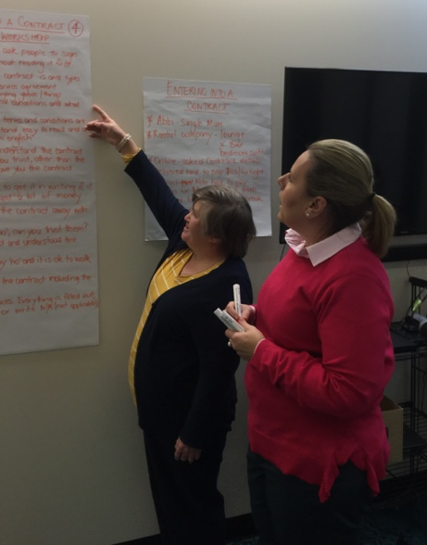
- Tips on co-production from the CID Team

- Planning is important.

•Everyone should be involved in making the plan.
•Everyone should understand the plan.
•The plan should give enough time to do things.

- It is important for people to be open to trying new things.

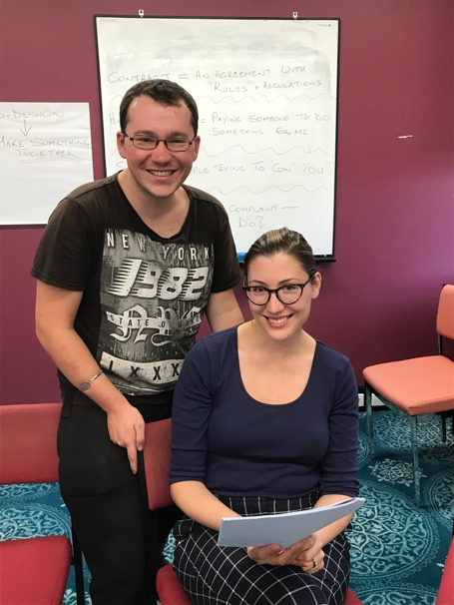
3. Having enough time to get to know each other at the outset to:
•build trust
•learn how people like to work
•know how to best support each other
•work well as a team.

- Develop Worksheet
Topic | Key Questions | Ideas | Your Project- your actions
Learning Together  - Say what you mean and mean what you say.  - Be vulnerable  - Remember the role of respect  - Give the benefit of the doubt  - Express your feelings functionally, especially when it's tough.  - Take a risk together  - Be willing to give as well as receive | - How do people in the room learn?  - Do we know how to work together to we get the best from each other?  - How can we value what different people bring to the room?  - What can we do to build trust?  - How we make sure we listen carefully and pay attention to the quite voices and the silences?  - Will what we produce work for the different communities we are trying to reach?  - Do we need to create different content for different audiences?  - Do we need content in different languages?  - Do we have lots of examples in our content?  - How do we accommodate people who learn differently? | - Create a map of how people like to learn and what works best for them in terms of contributing  - Run a fun session on “I am really good at..” for all  - Get to know someone else’s life. Make time for listening to stories about the impact of the issue  - Make a map of what you are doing – make sure everyone agrees to the map  - Share a meal  - Work out what you do when you disagree before it happens  - Allow time for people to say what they value about each other  - Allow time – then allow more time  - Be open to be surprised – expect the unexpected  - Think about the accessibility of your content  - Think easy English / easy read  - Use loads of images and make sure they represent the diversity of the community  - Stories are part of the content we develop so that people in communities can relate
Developing content

- Value co-production
- Have regular communication
- Have a structure or not?

- Transcript: Co-design – Deliver
We've got a really big peer network and people with disability,
we just want to share everything we know
and it's really good to do it on Facebook
and I think it's really good
for me personally to do a video

I did a few tips but this is our queen, who -

No I'm not!

You are

You are so liked on social media and people connect with you
We used to discuss tips, you did it really well

I did some scam ones and we mixed it up,
we did a bit of each
Some knowing your rights as a consumer
and where to go when you,
you know, need to make a complaint

“We're here at 2Dry FM in Broken Hill talking about scams.
The tax department will never ring you and if anyone does ring you...”

We used the community radio as an outreach
Letting the community know that we were out and about

2Dry FM 107.7 on your dial

In our presentations there was a lot around the language
and Leonie was really brilliant
when we have hard words or tricky words
Leonie was really good at bringing up other words
that we could use

I helped Belinda by explaining to her
different ways to help people with
an intellectual disability because as you know you can
make it too complicated with a lot of words
It needed to be in kinda plain English
and we preferred simple stuff
A lot of pictures things would have been better

“I'm pretty sure the NDIS was meant to, like,
you know, have some positive changes in my life
Yeah, all positive

Yep, yep, yep got you
Positive, positive”

Generally, we have a roleplay, or we put
in a video, or we'd do a little quiz
or something so it was a bit
different every time

We realised that, ours econd workshop,
we had to shorten it to make room
for the talking, for the interaction
It was more important to have the questions
and answers or for, you know,
given the floor, to be able to talk about
their own experience

We took our brainstorming to different parts
of the community and we shared our
life experiences

I contacted Mission Australia
and the first time we did go there,
there was a full roll up

I'm a peer support worker for Mission Australia
and I work in the Connections program
and I thought it would be good for
the group to get to know, like,
how they can go about complaints and
scams and all that kinda stuff

It was really informative
because I learnt a lot, you know
I knew some rights but not all of them

Alicia and Kelly - yes, you can
relate to them more because they've been
where you have been

Normally I used to ring my son,
say "Oh, you know, my boy,
I'm not happy with this or that,
can you ring them for me please?"
Yeah well, no, no...
I have a voice and I will use it

Yeah

- Transcript: Tania’s Tuesday Tips
Coming at you today with some top tips
for the week, to get you through with your loved ones
So, um...
my top tip for this week is it's Valentines Day
Some people love it, some people hate it,
but if you love it don't forget to love
your other partner, because you don't have to
spend a million dollars on them,
or even a dollar

You know, waking up in the morning, saying 'I love you',
is the best part about being in that perfect relationship
You know, um...
me personally I don't spend money on Valentines Day
I've got a beautiful husband of many years
and my life is strong and we tell each other we
love each other every day

So yeah, my top tip is don't forget to love your partner
Don't forget to, um...
if you love buying things and spoiling them
don't forget to do that but do it in moderation
Don't go overboard and leave yourself short for the week

Um... you don't need to go out and buy flash things
You know, a cheap old box of chocolates or something like that
It comes from the heart anyway, so that's what matters

And, um, yeah I guess that's a valuable top tip
So, Valentines Day on Thursday
so don't forget that guys!

So my next top tip for you guys this week
is, um.. on Thursday also CDAH
is running a Catch Up Crew
out at the Carrington Bowling Club in Newcastle
from 5:30 'til 8:30

Now our Catch Up Crews are awesome!
What we do is we all get together,
all of our CDAH members,
and we invite our friends, our families,
any mob that wants to come along
Um...

Come along and just enjoy the night
You know, make new friends,
have a feed, have a few drinks,
get very happy, have a laugh
Enjoy the night and enjoy the company
So, yeah, my other tip to you guys today
is to come on down to the Carrington Bowling Club
in Newcastle at 5:30 on Valentines Day

Hey, maybe you'll meet your Valentine - who knows?
Um, yeah and...
come and say g'day to me
and to a lot of the other CDAH members

We'd love to see you there, so yeah - cheers
That's Tania's Top Tips today,
coming at you from the comfort of my office

So, um, happy Valentines Day
Hope to see you Thursday at the Catch Up Crew
and love you, cheers for now.
- TnT Design and Delivery models
(from independent TnT evaluation, Dec 2018)

Partnership | Design | Delivery | Why this approach?
Council for Intellectual Disability | •A series of four workshops –one for each topic (scams, making a complaint, entering a contract, hiring a service; hiring a service and contracts also combined in one workshop)  •Spinning wheel and videos to engage participants and reinforce messages  •Examples of scam emails  •Peer facilitator told personal stories  •Role plays to share information | •Delivered sessions at organisations they knew  •One peer facilitator leads each workshop  •Fair Trading facilitator prompts peer facilitator and supports role plays  •CID worker provides support  •Resources: contact list for when scammed, how to make a complaint checklist, other Fair Trading resources | •Script was difficult for peer facilitators to remember, so changed to Fair Trading facilitator prompting peer facilitator, which worked better  •Delivery style designed to
Being | •In main locations: a series of four workshops –each covering a different topic  •In more remote locations: one-off workshops, covering one or more topics  •Design centred on purposeful storytelling  •Game to support understanding  •Spinning wheel to reinforce information  •Role plays to share information in some locations | •Worked with some existing groups  •Peer facilitator/s lead workshop  •Fair Trading facilitator provides support with information on consumer rights  •Being worker provides information and prompts as needed  •Delivery style varied by location and number of peer facilitators  •Resources: contract checklist, merchandise, cards with tips | •Decided on one topic per workshop as easier for peer facilitators to remember  •Delivery style suited to audience, with some differences to suit peer facilitators –some of whom were experienced facilitators  •Needed to be mindful of language used and stories shared to prevent triggering for peer facilitators and participants
Community Disability Alliance Hunter | •Tania’s Top Tips on Tuesdays (Facebook video posts) and Suzy’s Super Suggestions on Sundays  •Yarning circles/ NDIS gatherings –with facilitators sharing their experience with the four topics (e.g. hiring a service)  •Follow-up supports for participants | •Initially connecting through community networks, NAIDOC events and sharing merchandise  •Two peer facilitators generally at each gathering  •Holding gatherings at Aboriginal organisations, working with Ability Links and NDIS Local Area Coordinators to support participants  •Providing food and transport to gatherings  •Later re-focused on peer-to-peer in-depth support, going to meet people where they are | •Need to engage Aboriginal organisations and build long-term relationships  •Attract interest through events, flyers and merchandise  •Informal conversation approach suited to
Diversity and Disability Alliance/ Ethnic Community Services Co-operative | •All four topics covered in one session  •Scripted  •PowerPoint with pictures  •Message “Never give up” | •Two peer facilitators at each session (with a back-up if needed)  •Peer facilitators each have scripted sections of the workshop to deliver and are able to deliver as suits them  •Fair Trading facilitator asks questions and answers audience questions  •Resources: Fair Trading information sheets at some workshops, SkimGuard (very popular) | •Peers each felt comfortable with their scripted sections  •Having multiple peer facilitators and people to provide back-up helps to manage workload

- Standard 1: Excerpt from National Standards for Disability Services

Standard One:

Rights
The intent of this standard is to promote ethical, respectful and safe service delivery which meets, if not exceeds, legislative requirements and achieves positive outcomes for people with disability. The Human Rights principles are relevant across all the standards and each standard supports the achievement of basic rights. This standard has a focus on particular rights such as self-determination, choice, privacy and freedom from discrimination.
The standard recognises people’s inherent right to freedom of expression and the right to make decisions about and exercise control over their own lives. It reinforces the fundamental right of people with disability to have respect and dignity. This includes the dignity of risk - the right to choose to take some risks in life.
The standard acknowledges the risks of harm, neglect, abuse or violence which some people with disability may face when using services or supports. The standard highlights the roles for services and supports, families, friends, carers and advocates in reducing these risks. The standard promotes individual rights and individual and service responsibility.
The standard emphasises the importance of:
- dignity and respect;
- freedom of expression;
- self-determination;
- choice and control;
- confidentiality and privacy;
- freedom from discrimination, exploitation, abuse, harm, neglect and violence;
- the role of families, friends, carers and advocates in the safeguarding of rights; and
- comprehensive systems to prevent or promptly respond to any breaches of rights.

Rights for people
I have the right to exercise control and choice when I use services or supports. I also have the right to dignity of risk and to be free from discrimination or harm.

Outcomes for people
I can make choices about the services and supports I use, and how I use them. When I use a service or support, I am respected and safe

Standards for service
The service promotes individual rights to freedom of expression, self-determination and decision-making and actively prevents abuse, harm, neglect and violence.

Indicators of Practice
1:1 The service, its staff and its volunteers treat individuals with dignity and respect.

1:2 The service, its staff and its volunteers recognise and promote individual freedom of expression.

1:3 The service supports active decision-making and individual choice including the timely provision of information in appropriate formats to support individuals, families, friends and carers to make informed decisions and understand their rights and responsibilities.

1:4 The service provides support strategies that are based on the minimal restrictive options and are contemporary, evidence-based, transparent and capable of review.

1:5 The service has preventative measures in place to ensure that individuals are free from discrimination, exploitation, abuse, harm, neglect and violence.

1:6 The service addresses any breach of rights promptly and systemically to ensure opportunities for improvement are captured.

1:7 The service supports individuals with information and, if needed, access to legal advice and/or advocacy.

1:8 The service recognises the role of families, friends, carers and advocates in safeguarding and upholding the rights of people with disability.

1:9 The service keeps personal information confidential and private.

- Transcript: Romance scam
We developed a romance scam
I told a story about my friend
and they were like, oh yeah, let's kinda run with that
but let's split the roles.

So Michelle was this really sexy sounding
International British lady who lived in New York,
met me online, started it off kinda slow

"Hey honey, you look good
You're exactly what I look for in a man
What do you do, how's your family?
Oh I'm from a rich family"
All this kind of stuff and, like,
then we had, like, two months later
She'd constantly call me

She graduated to "Babe, honey
I'd really like to come and visit you
I'd really like to take a trip to Sydney
to come and visit you"

So I'm getting, like, all hot and heavy
I'm believing these pictures she's sending me

Then the bait kinda comes in, she says she's coming
I get all ready; I'm going to meet her at the airport
and then something goes wrong

“Oh darling, how you doing? I'm at the airport
oh my god I am so excited,
in about five to ten minutes I'm going to be on
that plane baby cakes
Next stop, Sydney!”

“I'm going to meet you at the airport
I've hired a car and everything
and I'll bring you to my place, yeah
I been dying to meet you”

“I know I love you too
I can't wait to meet you,
mwah, mwah, mwah

Bye darling bye, bye, mwah!”
Sucker... Right what am I having for tea?

“Steve? Steve, hi darling, oh babe
Guess what, you'll never believe what's just happened”

“Hey, what's going on babe you called me just, like,
ten minutes go, what's up?”

“So I was just about to get onto the plane
Somebody ran past and grabbed my bag
They've taken my bag which had my passport
and all my cards, I can't get on the plane!”

“Look, there is a solution. OK so I can actually
get my passport processed.
I can be on the next plane in 24 hours, yep
OK so all I need, I need six thousand US dollars”

“Gee, that's gonna be a bit difficult.
I don't have, like, six thousand dollars”

“Oh, can't you borrow it?”

“I'll have to think about it. Usually I ask my sister
before I make, like, big decisions like that
I mean, I did sell my car recently
I've used some of the money
but I'll add two thousand of it to the amount
to make up the six thousand”

“Look darling, I can have that back to you
as soon as I get into Sydney.”

“All right, sweet, I'll call you back soon darling”

“Oh darling, I love you so much. Bye”

OK bye darling, bye, bye”

Ahahah! Loser!
Oh my god look where I'm going with that money
Oh my god, weh-hey!

- Deliver Worksheet

Topic | Key Questions | Ideas | Your Project- your actions
Outreach  - Get the message to your audiences  - Utilise people with lived experience to connect  - Get your message clear | - Who is your audience and how can you reach them?  - Does everyone involved use the same language?  - Do you understand what is needed to communicate to your audiences?  - Communication chancels- what works best for whom  - What’s your message and why do people need to know? Or do you know your pitch?  - Who is good at what when it comes to delivering content?  - What are good aids to make sure the content lands with people?  - Do we need to change our content to fit the different needs of the audience?  - Should you have different strategies to make sure everyone has a chance to understand the content?  - Do you need an interpreter? Do you know how to work with an interpreter? | - Have a session on what the key messages are with everyone involved  - Practice the Pitch (imagine you have two minutes in a lift to get the message across to someone)  - Think about social media, radio, TV – but most importantly, use the networks of everyone involved and think about the power of word of mouth to get the message out into communities  - Some of the people involved in the co-design process become spokespeople/ ambassadors for the project  - Use other hot topics to get exposure for your project  - Map the strengths of the different people involved to deliver your content  - To deliver your content, think presentations, roleplays, tweets, radio spots, podcasts, short videos, quizzes.. what else?  - Know who the local Aboriginal and Torres Strait Islander peoples are and name them in your acknowledgement of country  - Leave lots of time for questions  - Promise people who get back to them if you don’t know something – and make sure you do
Delivering content

- Understand and connect with your audience
- Be personable
- Keep it easy
- Mind your language

- Transcript: Co-design – Debrief
After each session we get feedback that's useful
We would gather and we talked
about how the audience engaged

We definitely reflected
We had discussions during
the course of, and after,
each session on how it went

One session we'd do the presentation
and then we'd come back
and we would have a good talk about it
and say “Oh that was a flop”
or “That really worked”
and so we'd alter it that way too

When the co-facilitators were here
to deliver the workshop
to the carers, Vietnamese carers group,
they have children with disability,
like similar disability with the facilitator,
and they look at them as a role model

Sometimes, people in the audience would say to me afterwards
"Oh now that I've seen what the peer facilitators can do
maybe my son or daughter can do that”

The best thing I thought about was learning new skills
and being with other people and having an income

This is the first job in my life in Australia
that I work. My English get better
and confident to read and speak louder
and I can share my own story

I think I'm more confident than I would've been two years ago
and I even, you know, made a complaint a couple of weeks ago

I did adapt through my personal experiences
and I'm not shy anymore It's all about being
proactive and adapting

The thing that was good about the Fair Trading was
I get more confidence. Now talking to people
new people is not afraid, it's easy to do so

This project was a really fantastic opportunity for us
to set a standard for how co-design, how meaningful co-design,
can actually work: leading the design, leading the workshops,
facilitating, being part of the evaluation.
It needs to be cohesive in that way

You know, when I was coming home from
the actual workshop delivery, you know,
I didn't really need a train, cause I could float

One thing I've learnt was that I'm actually quite a good supporter

We have a lot more contact now

Yeah

It's funny how when you meet somebody and then all of a sudden
you become friendly with that person you met
through something totally, you know, unrelated

So, you know, it's good

We've got a friendship now

- Reflective Practice
Excerpt from

Reflective Practice -Why different points of view matter
From a workbook developed for National Disability Services by: Barbel Winter, Managing Director, futures Upfront and Maria Katrivesis, Consultant and Trainer July 2016
  - What is reflective practice?
Reflective practice is “a set of abilities and skills, to indicate the taking of a critical stance, an orientation to problem solving or state of mind” (Moon, 1999: 63).
It is the process of reflecting on our experience to improve our actions and professional practice. It involves looking at how and why we think and behave in any given situation. It’s about being conscious and aware of our actions and their consequences. It forces us to question what it is that we know and how we have come to know it.
A wide range of activities associated with thinking and learning about our work practices such as:
- self and peer assessment,
- problem-based learning,
- personal development planning, and
- group work
Can all be used to support a reflective practice approach.
Reflective practice encourages you to develop self-awareness and critically think about how our cultural frameworks, values and beliefs impact on our interactions with others. Regular reflective practice helps increase your awareness of your personal lens(es). It can support you to develop a greater level of self-awareness about the nature and impact of your work performance, which can lead to opportunities for professional growth and development.
  - Thoughtful Action vs Reflective Practice
Reflective practice is different to the everyday thoughtful action, or reflection on the go:
Thoughtful Action | Reflective Practice
Is instantaneous – one decides what to do next, thinking about it for only a split second | Requires one to take time out to reflect. It involves a conscious attempt to plan, describe, and reflect on the process and outcomes of the action
There is no cycle of clearly defined separate phases. It is an unpredictable sequence because one responds to events in the situation itself. | It is a clear cycle of separate moments in which one engages in completely different activities.
There is no describing moment, because one is engaged in acting. | As reflection occurs after action, one creates an observational record and describes the results of the action.
One is not aiming at an improvement to the practice. One is thinking about how best to do what one always does. | The major aim is to produce an improvement to the practice.
There is no element of inquiry and one is not deliberately setting out to learn something from experience. | One designs and uses inquiry strategies to find out more about one’s practice.
(Phillips, Bain, McNaught, Rice, & Tripp; 1999)
  - Thinking on your feet vs Reflective Practice
All of us, at some moment in our day or week, will need to react and make a decision very quickly. We reflect briefly on the situation and make a decision based on that momentary reflection. This is sometimes called: “thinking on our feet” or “reflection on the go”. People say that during these times they are operating on their instincts and are relying on previous experience and their skills to get them through the situation. These are very valuable skills to have. They enable us to act quickly. During these moments we are thinking about how best to do what we have always done. There is no element of inquiry and we are not deliberately setting out to learn something from this experience.
Reflective Practice is a conscious attempt to plan, describe, and reflect on a process and outcomes of an action. The major aim is to produce an improvement to work practice. To do this we need to consciously take time out to reflect. It involves a clear cycle of separate moments in which you are engaged in completely different activities. This is quite different to “thinking on your feet”, and allows you to share your thought processes with others, thereby not just benefiting your own learning but the learning of your teams and organisation as a whole.
  - How do we do Reflective Practice?
There are many tools and resources available to help you reflect on your work practice: what they all have in common is a process that enables you to look back or observe what happened, reflect and learn, and identify and apply a different approach next time.
This section will introduce you to two of them:
- Reflective Practice Cycle
- Johari Window Model
    - Reflective Practice Cycle:
One simple approach uses four discreet stages. Each stage involves asking yourself a series of critical questions in order to ‘unpack’ a situation and understand it from a range of standpoints, including your own and other people’s. It challenges you to think about your assumptions and identify any underlying issues that may have impacted on the situation. It acknowledges that it is okay to make mistakes as long as we learn from them.
The simple diagram below describes the four stages of reflective practice. These are:
- Describe
- Reflection
- Implementation
- Evaluation
Fig 1: Reflective Practice Cycle:

Reflective Practice Key Questions:
Below outlines some of the key questions for each stage of the reflective practice cycle to help you unpack and reflect on the situation or event.
1. Describe (the situation)
Consider:
- What do I understand about the current situation?
- What assumptions am I making?
- What are the underlying issues?
2. Reflect (on what happened)
Consider:
- From whose point of view am I seeing the situation?
- How do I test my assumptions?
- Do I need to address any of the underlying issues?
-What skills do I have?
-What skills do I need to develop?
3. Act (Determine how you would respond next time/in a similar situation)
Consider:
-(New) strategies I will now implement?
-What impact will this have on my work practice?
-What impact will this have on my organisation?
4. Review (your actions)
Consider:
-Has there been change?
-How have I shared the learning?
Like everything, it takes practice to get used to asking yourself these types of questions, especially when you have to think about your assumptions and preconceptions. It can be easier to reflect on our work practice when we can sit with others and think critically about it. The reflective practice framework described above in figures 1 and 2 is a great tool that can be used as an individual exercise or in a team environment. By developing and using reflective practice you will be able to bring forward ideas to help improve and enhance you own practice and the practice of others. Reflective practice can be a useful tool for sharing individual learning and improving overall team work-practice. In this context, reflective practice becomes a powerful tool for building individual and organisational cultural competence. For more information about cultural competence and person centred practice see Workbooks 2.3 and 2.4.
Have a look at this video.
What did you notice? What didn’t you notice? Why?
Building our self-awareness is a critical skill and the first step for developing person centred practice across cultures. It can be difficult to develop self-awareness on our own. As the video above “Test your awareness” demonstrates, we don’t see our own blind spots but we can be a mirror for other people’s blind spots as they can be for ours.
    - The Johari Window:

The Johari Window is a simple tool for looking at and developing self-awareness and understanding between individuals within a group. Initially developed by Joseph Luft and Harry Ingham it is used in both business and organisational contexts.
The Johari Window can be used to document information; including feelings, experience, views, attitudes, skills, intentions, motivation, within or about a person, or in relation to their group.
It is a very useful tool to help you identify your blind spots or those of your team. It is most effective when used by teams that have already established trust and have confidence in each other.
This is viewed from four perspectives:

Know to self Not known to self
Open | Blind
Hidden | Unknown

Know to Others

Not Known to others

- What is known to you about yourself and also known by others (open area)?
- What is unknown by you about yourself but which others know
(blind area)?
- What you know about yourself that others do not know
(hidden area)?
- What is unknown to you about yourself and is also unknown by others (unknown area)?
This model can be used in a reflective practice session with your team to increase self-awareness of individuals and groups to managing response to change.

27. Impact: Participant Outcomes
excerpt from TnT evaluation
Partnership | Positive Outcome | Challenges
Council for Intellectual Disability | •Learned about how to make a complaint, types of scams, and how to get help, including from Fair Trading  •Feel empowered and inspired by the peer facilitators leading the workshops – “I have a disability and I can do this too”  •Other outcomes for individual participants include confidence to make a complaint and reinforcing knowledge | •People have learned not to complain because they fear they may lose services  •Complaints processes can be difficult to access
Being | •Learned about how to read contracts, check contract terms and conditions, use the Fair Trading checklist before signing a contract, and how Fair Trading can help  •Other outcomes for individual participants include sharing information with friends | •The lack of services in some locations means people feel there is not an alternative to a poor quality service or fear that they will have no service if they complain  •People with psychosocial disability can question themselves, so may not feel confident to make a complaint
Community Disability Alliance Hunter | •Connected with people with disability (where may not have done so before)  •Received support to access assistance with primary needs  •Increased understanding of how to make the most of an NDIS plan e.g. the right to change coordinator supports and providers, self-manage (in some cases, this information has been shared through community organisations who attended workshops) | •Some people haven’t got an NDIS plan yet so aren’t ready for the message about their right to complain  •Some people are struggling with their NDIS plans so focused on this rather than consumer rights education  •People may not complain because of distrust of government, previous negative experiences with government processes or fear in a small community that everyone will know your business  •Written complaints process is inaccessible
Diversity and Disability Alliance/ Ethnic Community Services Co-operative | •Learned about their rights  •Increased confidence to stand up for their rights  •Outcomes for family members and carers included identifying potential opportunities for their children to have a role contributing to their community like the peer facilitators | •People may not be familiar with the concept of consumer rights or have trust in government processes because of experiences in their home country  •People may be reluctant to complain  •Reading contracts in a second language is difficult

28. Transcript: The benefits of co-design

The benefits for government when you include
people with disability at the very early stages
of designing programs and policy
is that it becomes more authentic

The outcomes are better
It'll be more targeted when you're using
people with lived experience
You'll also probably save money

The benefits of co-design work both ways
Our communities are also receiving expertise back
because we are working hand-in-hand
with government

So within the TNT project,
people getting a greater understanding
around Consumer Law

Anybody who's looking to co-design,
definitely give it a go

So at the end of the day, though,
co-design is really important
What it does is it provides better outcomes
and it does make the world more inclusive,
because you're acknowledging
and trusting different people with different voices
to know what they need and helping them
deliver those outcomes.

